

PATNA SCIENCE COLLEGE

ONLINE COMPLAIN MANAGEMENT SYSTEM

This project is submitted in partial fulfillment of the requirement for award of the degree of

Masters of Computer Application

### Carried and submitted by:

Kumari Aparna (14)

Chanda Rani (07)

**Session 2018-2021**

### Under the Guidance of

Mr.ANISH KUMAR

mR.NIRAJ SHARMA

### Department Of Statistics

PATNA SCIENCE COLLEGE

Patna University

College with Potential for Excellence (CPE) status accorded by UGC

Gratitude takes three forms.

“A feeling from the heart, an

Expression in words and a giving in return”. We take opportunity to

Express our heart full dedication

Of this piece of work.

*TABLE OF CONTENTS*

**CONTENTS**

Certificate of approval

Certificate

Acknowledgement

Project report

Title of the project

About company

Introduction and bjectives

Requirement specification

Project category

Tools and environment

Specific requirement

Functional requirement

Reasons for proposing tools

Analysis and design

Data and flow diagram

Entity Relationship Diagram

Database design

Hardware and software Requirement

System Coding

Screen layout

Security Mechanism

Validation Check

Limitation of project

Future Scope

Bibliography

DEPARTMENT OF STATISTICS

**CERTIFICATE**

This is to certify that the following students

KUMARI APARNA (14)

CHANDA RANI (07)

Have completed the project entitled **“ONLINE COMPLAIN MANAGEMENT SYSTEM”** is partial fulfillment for the award of **MASTERS OF COMPUTER APPLICATION** of the **PATNA SCIENCE COLLEGE, PATNA UNIVERSITY** during the academic year **2018– 2021**. The project report has been approved as it satisfies the academic requirement in respect of project prescribed for the Bachelor of Computer Application Degree.

Internal External

Head of the department



PATNA SCIENCE COLLEGE

DEPARTMENT OF STATISTICS

Patna University

**College with Potential for Excellence (CPE)**

Status was accorded by the UGC

acknowledgement

T

**he internship opportunity I had with KIBA LABS(BANGALORE) was a great chance for learning and professional development. Therefore, I consider myself as a very lucky individual as I was provided with an opportunity to be a part of it. I am also grateful for having a chance to meet so many wonderful people and professionals who led me though this internship period.**

**No task however small can be completed in a hostile & uninspiring environment , Thus I wish to thanks every person who directly or indirectly helped to create a congenital atmosphere for me to work in & successfully complete my project.**

**I express my indebted heartful gratitude to Mr.ANISH KUMAR for giving me the opportunity to do the project in Megasoft & providing me with his great learning experience.**

**I express my deep sense of gratitude, whole hearted thanks to Mr.NIRAJ SHARMA,KIBALABS for his invaluable all around guidance & encouragement,which has played the important role in the completion of this project , his encourage from time to time helped me to travel along with the project & eventually to the completion to the project. Special thanks to Mr.Ravi RAJ GOPE for helping us satisfy our queries regarding project on time.**

**I perceive as this opportunity as a big milestone in my career development. I will strive to use gained skills and knowledge in the best possible way, and I will continue to work on their improvement, in order to attain desired career objectives. Hope to continue cooperation with all of you in the future,  
Sincerely.**

**I would also like to thank my friends and Family whose guidance and help make us able to complete my project successfully.**

**Regards:**

**Kumari Aparna,Chanda Rani**

***PROJECT ON:***



FOR

KIBA LABS PVT LTD.

(BANGALORE)

PRESENENTED BY:

KUMARI aPARNA(14)

CHANDA RANI(07)

**Online Complain Management System**

**KIBALABS**

ABOUT COMPANY



KIBA LABS Pvt. Ltd. is reckoned as one of the most trusted it based service providers,specializing in back-end services in the spectrum of human resources ,finance & accounting and information technology.In this, company offers payrolls, compliances HRMS ,accounting and finance and ERP solution s with integration of technology.

The company headquartered in Bangluru, India. Since 2019.we are best with our forecasting system which allow clients to consistency hit their goals. Our work has resulted in a substantial growth for our clients .We have been recommended for our timeliness and proactively.

.



Kumari Aparna (14)

Chanda Rani (07)



1. **Introduction and Objective Complain Monitoring System**

These days, computer has revolutionized the working environment in almost all real life organizations. Since working on computer is nothing if we do not access Internet so when we browse through various sites, sites may contain malicious items that harms our system so there is a need of antivirus to deal with it. Also we need to connect computers within Local Area Network. There can be a problem of Lease Line or Broadband connection.

* Easy to lodge complaint.
* To view the status of complaint by entering complain number and viewing the action taken on that problem and the officer that attended.
* To monitor the handling of various types of complaints and rectifying them in proper manner.
* To categorize the complaint officer that deal with different type of complains.
* Easy to check daily report of different complains by viewing the scenario of status of complains that is whether they are over or still pending with concerned complain officer.
* Easy to filter complains on various criteria’s.
* Easy to edit information or for the new entry when login through admin.
* The total number of complaints can be seen in overall bases as well as according to different status of complains.

Organization couldn’t achieve proposed objectives by manual system. The project entitled as “COMPLAIN MANAGEMENT SYSTEM” proposed to handle the CMS allows rectifying complains faced by person in various departments and getting the service on their place only. CMS keeps & maintains following information:

**ONLINE COMPLAIN MANAGEMENT SYSTEM**

KIBA LABS(BANGAROLE)

* Complain handling officer detail
* Complainer detail
* Department detail
* Sites Detail
* Performance detail
* Login detail

As this information are temporary in behavior means changes time to time such as: - More sites can be added in near future. Also more number of departments can be included when sites are increased.

**Objectives:-**

Since last few years, the need of such system was felt that there should be ease to lodge complain and get it solved by just click of the button. The person that will solve your problem can be contacted easily. The officer’s. Here the project “COMPLAIN MANAGEMENT SYSTEM” has achieved the following objectives in favor of employee Information:-

* **Accuracy:**The system is accurate. Thus, its utility is very high.
* **Flexibility:**The system is such that changes and modification can be easily incorporated in it.
* **Reliability:** The system is reliable, as the person gains access on the basis of his/her user identity.
* **GUI:** The system gives Graphical Interface, so it’s User friendly.
* **Modularity:** The system has relatively independent and single function part that can be put together to serve the purpose.

**ONLINE COMPLAIN MANAGEMENT SYSTEM**

KIBA LABS(BANGAROLE)

* **User friendliness:** The system is easy to learn and understand. A negative user can also use the system effectively, without any difficulty.
* **User satisfaction:** The system is such that it stands up to the user’s expectation.
* **Probability:** The application can be easily move from on hardware to other.

**2. REQUIREMENT SPECIFICATION**

Once the analysis is complete, the requirements must be written or specified. The final output is the Software Requirement Specification Document (SRS)

The purpose of Software Requirement specification is to bridge the communication gap between the client and the users. SRS is the medium through which the client and user needs are accurately specified indeed, SRS firms the basis of software development.

***Characteristics of an SRS:-***

A good SRS is:

* Understandable
* Unambiguous
* Complete
* Verifiable
* Consistent
* Modifiable
* Traceable

**ONLINE COMPLAIN MANAGEMENT SYSTEM**

KIBA LABS(BANGAROLE)

* Functionality
* Performance
* Design constraints imposed on an implementation.

***Components of an SRS:-***

The basic issues which an SRS must address are

***Figure –components of an SRS***

Software Requirement

Specification

Before going for the computerization of any system, the existing system must thoroughly be understood to determine how the computer can best be used to make its operation most effective. Hence “REQUIREMENT ANALYSIS” is the process of diagnosing problems, gathering and interpreting facts to improve the system performance.

**ONLINE COMPLAIN MANAGEMENT SYSTEM**

KIBA LABS(BANGAROLE)

The minimum hardware & software requirements are as follows:

***Complain Monitoring System consists of following modules:***

1. User module
2. Administrative module
3. Officer module

**3. PROJECT CATEGORY (RDBMS)**

The project category “ONLINE COMPLAIN MANAGEMENT SYSTEM” is falls under the category of two types of system:-

* WEB BASED
* RDBMS

**WEB BASED: -** The “ONLINE COMPLAINT MONITORING SYSTEM” is a web based project and a web is the synonyms of Internet. Web generally contains website. Websites contain web pages. This facility is provided on the Internet. But some people confused that it is an Internet but it is simply a part of Internet. It is generally used for information transaction. Features of websites:-

* It must be graphically strong because strong graphics make a good effect on customer.
* Information must be verified.

**ONLINE COMPLAIN MANAGEMENT SYSTEM**

KIBA LABS(BANGAROLE)

* Communication facility must be well.
* Editing must be possible.

**RDBMS: -**RDBMS stands for Relational database management system. RDBMS is developed by E.F. CODD for general purpose database storage without the duplication and redundancy. Our project is delicately falls in Relational Database Management System (RDBMS) environment; RDBMS is one of the important environment for commercial data and basically is used on the concept of entity/table. It is a database which has strong relational capabilities. Here by the term relation means a database which can deal with multiple database table at the same instance of time. Here we use MYSQL 5.5 for RDBMS tool. The MYSQL 5.5:

1. Updating the database.
2. Retrieving information from the database.
3. Accepting query language statement.
4. Enforcing security specification.
5. Enforcing data integrity specification.
6. Enforcing information consistency.
7. Managing data sharing.
8. Optimizing Query.
9. Managing system catalog.

**ONLINE COMPLAIN MANAGEMENT SYSTEM**

KIBA LABS(BANGAROLE)

**4. TOOLS AND ENVIRONMENT**

*TOOLS*

* CLIENT SCRIPT:- html , css , java script
* SERVER SCRIPT:-jsp
* DATABASE :- mysql

*MINIMUM HARDWARE REQUIRED*

* PROCESSOR
* RAM
* STORAGE
* DRIVES

*MINIMUM SOFTWARE REQUIREMENT/TECHNOLOGY USED*

* OPERATING SYSTEM
* RDBMS-MYSQL SERVER
* APACHE TOMCATE SERVER
* MYSQL JDBC CONNECTOR

**NETWORK TECHNOLOGY**

A network is a simply an Interconnection of two or more computers for the purpose of sharing information (data, schedule, email etc.) and resources (printers, storage, application etc.)

**ONLINE COMPLAIN MANAGEMENT SYSTEM**

KIBA LABS(BANGAROLE)

***Hardware components of network:-***

* **Server:** Computer that hold sharable resources. Server provides network services.
* **Client:**A client is any computer on a network that uses the service provided by the server.

***Software component of network:-***

* **Network operating system (NOS):**NOS is the software that runs on a server and control access to files and another resources.
* **Protocols**:P**r**otocols are the set of rules, which defines the procedures, convention and methods used to transmit data between two or more networked devices.

Example – **TCP/IP**

**Client/Server Architecture**

The project uses client/server Technology In which J2EE is used as Front End Tool and MYSQL 5.5 as Back End Tool, which is a hardware tool on window. Basic Purpose of this project is to use the database at different location of different users, so client/server model is best to choose.

**5. SPECIFICATION REQUIREMENT:-**

***User Interface:***

***1)*Inputs and Outputs:-**

The system has ten input forms by which any type of record regarding this system can be entered*,* and produced all of user’s requirement in the form of report.

All the report separately and according the user’s need, provides greater look and feel.

**ONLINE COMPLAIN MANAGEMENT SYSTEM**

KIBA LABS(BANGAROLE)

***2) Hardware:-***

The minimum hardware requirement for the proposed system is as given below:-

* Processor :- Dual core
* Ram :-1GB
* Hard disk :-120 GB
* Laptop :-15’’ color monitor
* Printer :-Laser

***3) Software:-***

The minimum software requirement for the proposed system is as given below:-

* Operating System
* Web Technology
* Front end tool
* Back end tool

The proposed had full capability to be used by one or more person at a time i.e., can be used in a multiple-user operating system environment (windows XP, Windows NT etc.)

***4) Interfaces:-***

The proposed system interfaces matches with commonly used window interfaces. Its interfaces is user friendly and anyone who knows the basics of computer can easily handle this E-commerce project.

***5) Behavior description:-***

It describes about the various type of event used in developing software.

**Events:**An event is any user action directed at the application. There are various types of event available, but we will discuss only events which we used in proposed application software.

**ONLINE COMPLAIN MANAGEMENT SYSTEM**

* **The Window Events: -**Associated with a window are events. The user write code that will be executed when a particular event occurs. Some window event are :
* **Click:**Occur when a user clicks on a window with the mouse.
* **Resize:** Occurs when users resize the window.

**The Command Button Events: -**Associated with a command button are seven events. The user can write code that will be executed when a particular event occurs.

*Some command button events are:-*

**Click: -**Occurs when a user on a command button with the mouse. This is the only event that is required of a command button. However the command button also support event such as:-

**Key Press: -**Occur when the command button is the current select element and the key is pressed on the keyboard.

**Get Focus: -**Occur when the command is made the current action element.

* **The Text Box Events: -**Associated with text box are several events. The user can write code that will be executed when particular event occurs.

Some text events are:-

**Key Press: -**This event is called each time Key is pressed with the focus on the text box.

**Change**: - Occurs each time the contents of the text box.

* **The Combo Box Events:-**The user can write code that will be executed when a particular events occurs.

Some combo box events are:-

**Click: -**Occurs each time the clicks on the Combo box.

**ONLINE COMPLAIN MANAGEMENT SYSTEM**

**Scroll: -**Occurs when a user scrolls through list in the Combo Box.

* **The Radio Button Events :-** While Radio Buttons support several events, the most commonly used is :-

**Click:-**Occurs when the user clicks on the radio button.

***6) Validation criteria: -*V**alidation are the necessary checks performed to make the program more reliable, efficient and strong. When the user passes the values would be checked to fall within the range, if values are incorrect or any data type error then an appropriate message would be flashed. Validations does not accept the wrong entries so the problem becomes more effective. In this project the validations are performed through the following fields:-

* Primary key
* Foreign key
* Limit value
* Null value

Validation also checks for data being entered in a particular format.

* Dates are to follow the ‘DD-MM-YYYY’ format.
* The table column where numeric entry is needed the Text Box allows user to the entry numeric entry.
* The table column where string type entry is needed the Text Box allows user to enter string type entry.

**ONLINE COMPLAIN MANAGEMENT SYSTEM**

***7) Classes of Tests: -***As far as the proposed system is concerned different types testing has been performed.

* **White Box Testing :-**
* Transaction Path Testing
* Module Testing
* String Testing
* **Black Box Testing :-**
* System Testing
* Output Testing
* User Acceptance Testing

Accept these Testing there are different other Testing are available. They are as follows:-

* Unit Testing
* Integration Testing

**6. FUNCTIONAL REQUIREMENTS:-**

For each functional requirement, the required inputs, desired output, and processing requirement will have to be specified. For the inputs, the source of inputs, the units of measure, valid range, accuracies etc. have to be specified.

The functional requirement of this system is that when a particular depot is clicked the particular information only displayed. First of all user should must be authorized and assign the password by the administrator of this office.

**ONLINE COMPLAIN MANAGEMENT SYSTEM**

**TOOLS AND ENVIRONMENT USED**

**Tool to be used**:-

There are two different tools used for this project:-

* Front end Tool
* Back end Tool

In my project J2EE is used as front end tool and MYSQL is used as backend tool.

**H/W & S/W requirements:-**

***HARDWARE REQUIREMENTS***

PROCESSOR

RAM

HARD DISK

MONITOR

KEYBOARD

***SOFTWARE REQUIREMENTS***

O/S

WEB SERVER

BACK END TOOLS

WEB TECHNOLOGY (Client)

WEB TECHNOLOGY (Server)

BROWSER

IDE

**ONLINE COMPLAIN MANAGEMENT SYSTEM**

**Network Technology: -** I am developing project for internet, so network technology is a major issue for this.

**H/W components:-**

***Server****: - A* server is a computer that contain sharable resources and it provides services to its client.

***Client****: -*A client is a computer that uses the resources of server.

**S/W components:-**

***Network Operating System (NOS):-****It* runs on the server and control the resources.

***PROTOCOLS: -***The set of rules are define to use the internet is called protocols. Normally we use TCP/IP as internet protocol.

**7. REASONS FOR PROCESSING THESE TOOLS**

There are two tools to be used for this project

**1. FRONT END TOOL**

**2. BACK END TOOL**

**ONLINE COMPLAIN MANAGEMENT SYSTEM**

Here, J2EE is used as front end tool and MYSQL5.5 is used as back end tool.

J2EE (Servlet, JSP, Java Beans), struts as a front end technologies facilitates user a comfortable web environment. J2EE is a technology that aims to simplify the design and implementation of enterprise applications. Its intelligence feature in code editor is very important and useful for the developer. It is very powerful language which is launched by the Sun Microsystems.

The need of now a day’s software development is competence in a web based application front-end to which can connect to relation database engine. This gives the programmer the opportunity to develop client-server based commercial application. This application gave user the power and ease of user of web based application with the multi-user capabilities of auto based RDBMS engine such as oracle. From the my point of view, Java(J2EE) is a simple and powerful object oriented programming language that is capable of developing robust and secure distributed application. Java is used not only for interactive Internet programming but also for developing standalone applications.

Java has many features in programming language. Such as:-

1. Simple object oriented
2. Multithreaded
3. Robust
4. Distributed
5. Secure
6. Platform Independent.

**ONLINE COMPLAIN MANAGEMENT SYSTEM**

Java was designated to be very simple and easy to learn. Thus we aware of the various object oriented concepts can easily develop applications in java. The multi-platform environment of the web places high demand on the reliability of the programs to execute on a Variety os system. Java is one of the rapid application development tools as it enables the programmers to develop application very easily and very quickly. Java is truly “OOPS” language.

* JAVA (J2EE) application supports:

1.Abstraction

2.Encapsulation.

3.Polymorphism.

4.Inheritance

5.Multithreaded

Java is a designed to be used in networked and distributed environment where security is of permanent interface. Java was designed to support application on heterogeneous network environments composed of a variety of processors, the operating system architectures and multiple programming language interfaces. To enables a java application to execute anywhere on the network. All coding techniques used by the programmer in oops and in great detail this is coupled with material on how to use the carrier tools.

This chapter provides a tutorial introduction to MySQL by showing how to use MySQL client program to create and use a simple database. MySQL (sometimes referred to as the “terminal monitor” or “monitor”) is an interactive program that

**ONLINE COMPLAIN MANAGEMENT SYSTEM**

Enables you to connect to MySQL server, run queries, and view the results. MySQL may also be used in batch mode: you place your queries in a file beforehand, then tell MySQL to execute the contents of the file. Both ways of MySQL are covered here.

To see a list of option provided by MySQL, invoke it with the –help option:

Shell> MySQL –help

This chapter describes the entire process of setting up and using a database. If you are interested only in accessing an existing database.

You may want to skip over the sections that describe how to create the database and the tables it contains.

Because this chapter is tutorial in nature, many details are necessary omitted. Consult the relevant sections of the manual for more information on the topics covered here. The goal of Struts is to cleanly separate the model (application logic that interacts with a database) from the view (HTML pages presented to the client) and the controller (instance that passes information between view and model). Struts provides the controllers (a servlet known as Action Servlet) and facilitates the writing of templates for the view or presentation layer (typical in jsp, but XML/XLST and velocity are also supported). The web application programming is responsible for writing the model code, and for creating a central configuration file struts – config.xml that binds together model, view and controller .requests from the clients are sent to the controller in the form of “Action” defined in the configuration file; if the controller receives such a request it calls the corresponding Action class that interacts with the application-specific model code. The model code returns an “Action forward”, a string telling the controller what output page on send to the client.

**ONLINE COMPLAIN MANAGEMENT SYSTEM**

Information is passed between model and view in the form of specific JavaBeans. A powerful custom tag library, allows it to read and write the contents of these Beans from the presentation layer without the need for any embedded Java code.

For Back-end we need a RDBMS package and due to exciting features of “MySQL” we use it as back-end. MYSQL is An Open Source, Enterprise-level, multi-threaded, relational database management system that stores and retrieves data using the structured query language.

It uses structured query language which is English like language due to which it is simple to making queries. MYSQL has large number of new features such as analysis queries, scalar sub-queries, joins, pivot insert statement and merger statement. It also provides the key concept such as primary key, unique key and foreign key. It provide you may to skip over the section that describe how to create the database and the tables it contains.

**8. ANALYSIS AND DESIGN DOCUMENT**

***PROBLEM DEFINITION:-***

Many people consider this to be the most important phase. It defines the problem to be solved and thus sets the direction for the whole project. It guides the software developer to how will the project will be solved out. It also defines the project bound and what parts are outside its control. The resource to be made available to the project are also specified in this phase. Mainly it consider to the first phase of developing the software because the problem can’t be solved out unless it is defined, so it is considered as a very important phase.The three important factors,the project goal, the project bounds and resources limits are sometimes called the project’s term of reference.

**ONLINE COMPLAIN MANAGEMENT SYSTEM**

**Phase Output: - The** phase output also contain a rough idea of the resource requirement of each of the subsequent project phase. It will tentative data completion dates for each and the number of person involved in each phase.

**FEASIBILITY STUDY:-**

The feasibility study proposes one or more conceptual solutions to the problem set for the project. The conceptual solution gives an idea of what the new system will look like. They define input will be needed and what outputs will be produced. These solutions must be proven feasible and a preferred solution must be accepted.

Three things must be done to establish feasibility. It is necessary to that the project is technically feasible. Does the organization in fact have the technology and skills necessary to carry out the project and, if not, how should the required technology skills be obtained? Operational feasibility must be established. To do this it is necessary to consult the system users to see if the proposed solutions satisfies user objectives and can be fitted in to current system operations.

Project economics feasibility should be checked. The study must determine whether the project’s goals can be determined achieved within the resource limits allocated to it. It must be also determine whether it is worthwhile to proceed with the project at all or whether the benefits obtained from the new system are not worth the costs.

**Phase output: -**

One out of feasibility study is preferred conceptual solution together with the excepted system costs and benefits. The plan in phase I has now been expanded into more details, showing resource requirements for each phase.

**ONLINE COMPLAIN MANAGEMENT SYSTEM**

**System Analysis: -**

A detailed analysis of the system is made in this phase to familiarize designers with the operation of the existing system. Analysis uses many of commonly used systems analysis techniques such as data flow diagrams data analysis during this analysis.

They also follow specified producers in this search for information about the system. Analysis must be spend considerable time examining components, such as the various forms used the system, as well as the operation of existing computer systems.

**Phase output: -**

This phase output results in a detailed model of the system. The model describes the system functions, system data and system information flows. The phase report contains any revisions to the project goal and cost benefits analysis estimates.

Finally, it specifies a set of objectives to enables the new system to overcome these problems.

**System Design: -**

This phase produces a design for the new system. System design is usually proceeds in two steps, Broad design and detailed design.

During Broad design the conceptual solutions proposed by the feasibility study are looked at more detail.

Important inputs and outputs are also defined at this point. In additions, Broad design outlines which part of the system is automated which will remain manual.

**ONLINE COMPLAIN MANAGEMENT SYSTEM**

**Phase Output: -**

The output of this phase include a proposed equipment’s configurations together with specification for database and computer programs.

Detailed user producers are also provided. These includes any input forms and computer interfaces between users and computers. The user manual is also at the end of this phase.

**System Construction: -**

This phase is often broken into smaller phase, development and implementation. The individual system components are built during the development period. Program are written and tested, and the user interfaces development and tried by users. The database is initialized with data. During implementations, the components built during development are put into operational phase. To complete the changeover, user be trained in system operation and any existing producers converted to the new system.

**Phase output: -**

At the end of the phase, users are the provided with a working system. This includes the set of working programs and an initialized database. In additions, any system documentations describing the program is also completed. All users have by now been trained and can be use the new system.

**SYSTEM ANALYSIS**

*IDENTIFICATION OF NEED: - As* we know that today is the age of information technology. Nobody can develop it any walk of life. Anybody has as more information they will be as powerful man.

**ONLINE COMPLAIN MANAGEMENT SYSTEM**

So in this point of view to develop an E-commerce project where the project must be supported to do work for purchasing of shoe by the customer and help the employees to receive the money receipt and check the payment status and then dispatch the shoe at the customer address.

Therefore, to get benefit there is a need of such project.

**PRELIMINARY INVESTIGATION: -**

When I had accepted this project the purpose is to provide information fatly to manage. Before starting this project or system some more information is required. Which are given below:-

* Get all the information about the project.
* Find out all the method through which I can develop.
* Find our best way or method among them.
* Understand the data flow diagram and flow chart that what actually these diagram ire.
* Think over these types of tools which support these are more suitable.

**TECHNICAL FEASIBILITY: -**

User, this feasibility has been seen that technical feasibility centers existing computer system, which are need for project.

* This project has been developed with the help of graphs, means this project requires graphic features method.
* So, to develop this project such types of graphics drivers, and software which is supportable for graphics method or function?

**ONLINE COMPLAIN MANAGEMENT SYSTEM**

To develop this project such types of graphics requirements is **‘120GB HARD DISK, 1GB RAM, DUAL CORE PROCESSOR, MONITOR, KEY BOARD, MOUSE, PRINTER’**  and software is required which is **‘WINDOWS 2003 SERVER O/S, J2EE,MySQL,APACHE TOMCAT WEB SERVER, JDEVELOPER IDE’.**

* Thus the requirement of this project is commonly available in the market or commonly available in standard system.
* If there is certain type of change is needed then it can be upgraded.

**ECONOMIC FEASIBILITY: -**

This method is most frequently used for evaluating the effectiveness of the system, must commonly know as cost benefit analysis. This procedure is used to determine the required benefits from the proposed system. This procedure is to determine the benefits and saving the excepted from a system and compare with them with cost.

This project has minimum of which are easily available in common computer system.

* The development of this project is not too expensive.
* This project has occupied no more memory.

**ONLINE COMPLAIN MANAGEMENT SYSTEM**

**OPERATIONAL FEASIBILITY: -**

Under this study we are going to find out that, the project is beneficial if they can be turned into information system that will meet the operating requirement of the **‘ONLINE BID MANAGEMENT SYSTEM’** which is an E-commerce project, where the operational requirement is to desirable.

* Are the current method accepted to the user. If user not accepts user may welcome a change that will bring about a more operational and useful system.
* Have the user been involved in such type of business.
* The system not cause any harm, and it will produce a better result.

**SOFTWARE REQUIREMENT: -**

After analysis of the problem of the software requirement is produced at the culmination of analysis task. The function and performance allocated to software as a part of system engineering are defined by establishing a complete information description, detailed functional description. The representation of the system behavior, an indication of performance requirements and designed constraints, appropriate validation criteria and other information pertinent to requirements.

The software requirement specification sets the goal and objectives of the software, describing it in the previous developed websites for e-commerce based application. It is an agreement, a contact between the client and developer on what the software product will do.

**ONLINE COMPLAIN MANAGEMENT SYSTEM**

**SOFTWARE ENGINEERING ANALYSIS**

The waterfall model is a software development model (a process the creation of software) in which development is shown steadily downwards (like a waterfall) through the phases of requirements analysis, design implementations, testing (validation), integration and maintenance. W .W Royce introduced the term in 1970.

The following phases are followed perfectly in order.

**REQUIREMENTS SPECIFICATIONS**

1. **Designing**
2. **Coding.**
3. **Integration.**
4. **Testing and debugging.**
5. **Installation.**
6. **Maintenance.**

* **Data Flow Diagrams**

In architecture design we created a Dataflow Diagram, which shows the flow in modules. In other words “**Data Flow Diagrams** are used to describe how the system transforms information. They define how information is processed and stored and identify how the information flows through the processes”.

**ONLINE COMPLAIN MANAGEMENT SYSTEM**

A Data Flow Diagram (DFD) is a graphical representation of the “flow” of the data through an information system.

There are only four symbols:

1. **Squares: -**Representing external entities, which are sources or destinations of data.
2. **Rounded Rectangle: -**Representing processes, which take the data as input, do something to it, and output it.
3. **Arrows: -**Representing the data flows, which can either be electronic data or physical items.
4. **Open-Ended Rectangle: -**Representing data stores, including electronics stores such as database or XML files and physical stores or filing cabinets or stacks of papers.

**Table**

|  |  |
| --- | --- |
| **Symbols** | **Description** |
| Input / output | Representing External Entities |
| File /database | Representing Data stores |
| Function | Representing Processes |
| Flow | Representing Data Flow |

**ONLINE COMPLAIN MANAGEMENT SYSTEM**

**Data Flow Diagram (CMS)**

1. **Level DFD**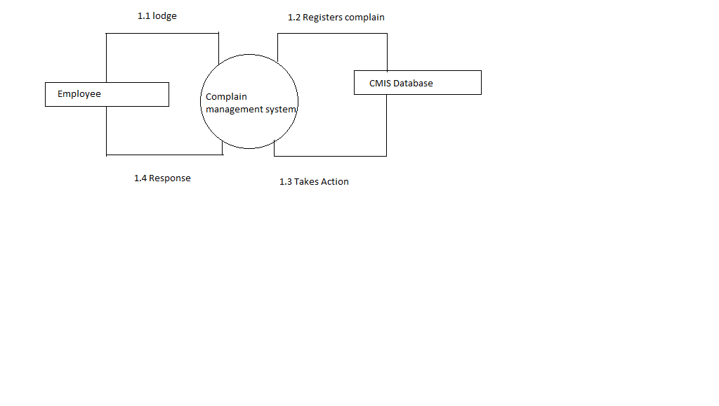

Figure: Context Analysis Diagram

|  |
| --- |
| * 1. lodges complaint   2. Request is passed to the complaint database by the system   3. Database respond to the complaint   4. Response (Action Taken ) is passed to the employee |

**ONLINE COMPLAIN MANAGEMENT SYSTEM**

**1.DFD Of User Module**

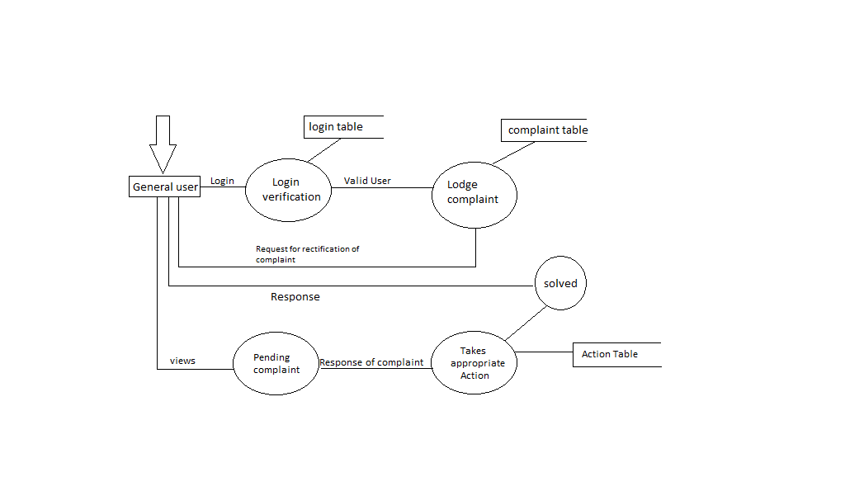

1. **DFD Of grievance engineer’s module**

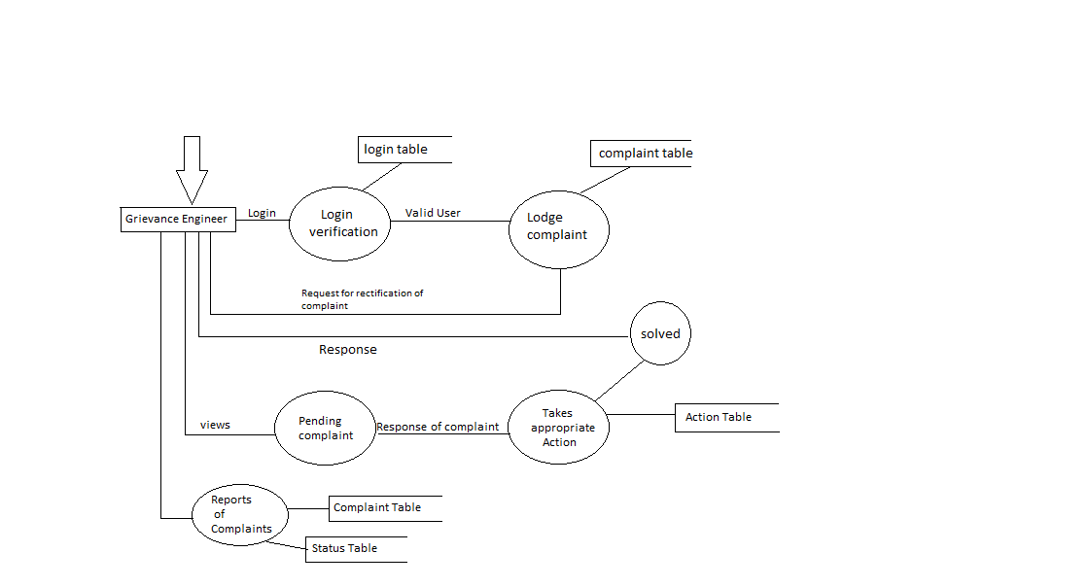

**ONLINE COMPLAIN MANAGEMENT SYSTEM**

1. **DFD Of Administrative Module**

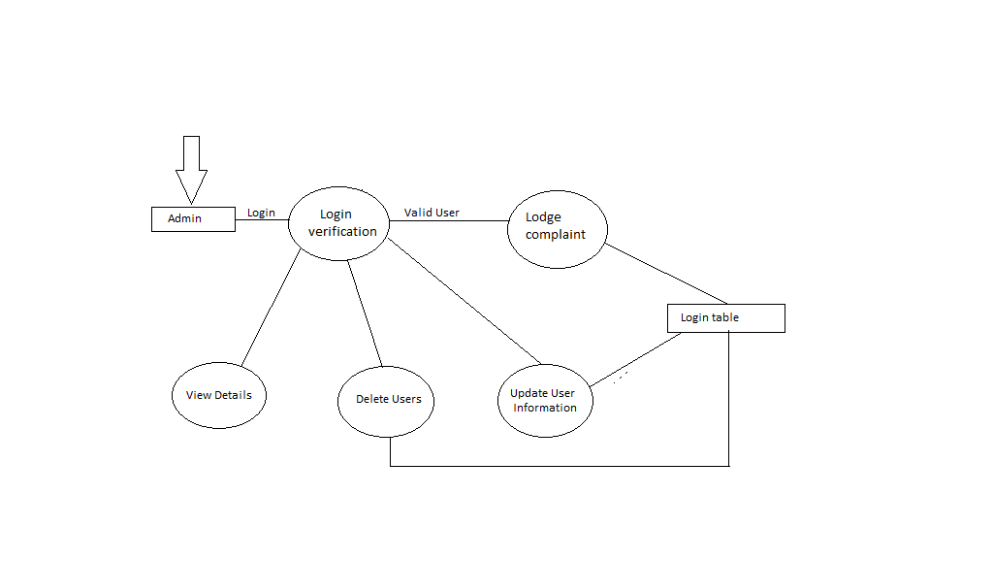

**ONLINE COMPLAIN MANAGEMENT SYSTEM**

**10. ENTITY RELATIONSHIP DIAGRAMS**

In database design E-R diagram is created to show Relationship between Entities and Attributes.

There are three basic elements in E-R models:

1. **Entities**are the “things” about which we seek information.
2. **Attributes** are the data we collect about the entities.
3. **Relationships** provide the structure needed to draw information from multiple entities.

***How to make Entity Relationship Diagram***

An E-R diagram expresses the overall logical structure of a database graphically.

1. Use **Rectangle** representing entity sets.
2. Use **ellipses** representingattributes.
3. Use **diamonds** representing relationship sets.
4. Use **lines** linking attributes to entity sets and entity sets to relationship sets.

|  |  |
| --- | --- |
| ER-diagram symbols | Description |
| **Ellipse** | Ellipses representing Attributes. |
| **Diamonds** | Diamonds Representing Relationship sets. |
| **Rectangles** | Rectangles Representing Entity sets. |
| **Lines** | Lines Representing Linking between Relationship set. |

**ONLINE COMPLAIN MANAGEMENT SYSTEM**

**E-R Diagram of BSPHCL**

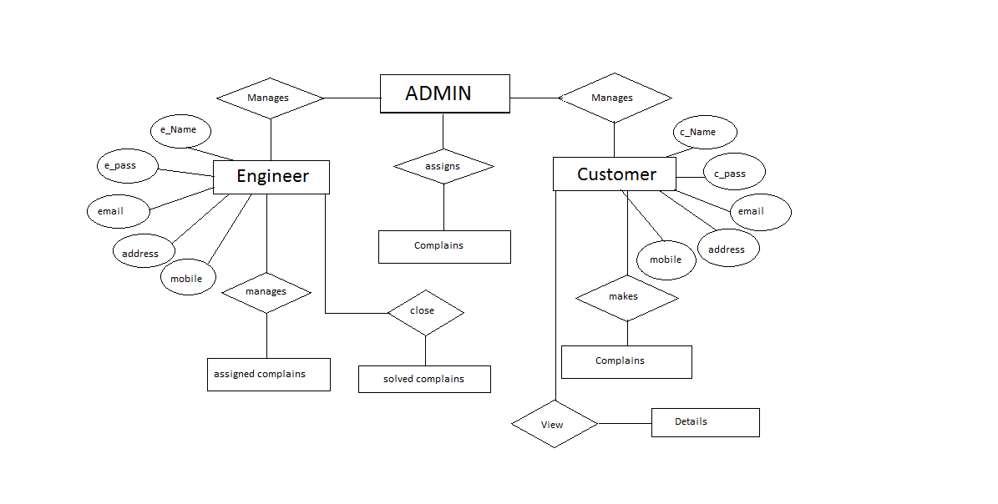

**ONLINE COMPLAIN MANAGEMENT SYSTEM**

***The E-R Diagram of COMPLAINTS contains the following Entities:***

1. Administration
2. Users
3. Engineers
4. Department
5. Complaint
6. Action
7. **Administration**:It explains the function and role of administration.

*Attributes*: user_name, pwd

1. **Engineer:**explain the general engineers that can lodge and solve the complain which is assign by the ‘admin’.

*Attributes***:** user_name,epass.

1. **Customer:** It explains the general customer that can lodge the complaints.

*Attributes* **:**user_name,c_pass.

1. **Status :**It keeps the status of complaints.
2. **Action :** Contains the information regarding action taken on complaint.

**ONLINE COMPLAIN MANAGEMENT SYSTEM**

**11. DATABASE DESIGN**

In our project “ ONLINE COMPLAIN MANAGEMENT SYSTEM” , we used mysql server for database design.

In our project we used following database having tables for data storage:

***Name of the database :*** CMIS

***Tables in the database:***

* Login
* Complain
* Deptmast
* Sitemast
* Statusmast
* Action
* Designationmaster
* Ctypemast

**ONLINE COMPLAIN MANAGEMENT SYSTEM**

***Tables***

The listof table written here which are used in database.

**ADMIN TABLE**

|  |  |  |
| --- | --- | --- |
| SI.No. | Field Name | Description |
| 1 | Id | Through which user login |
| 2 | Username | User name |
| 3 | Password | User password |
| 4 | Fullname | User full name |
| *5* | Phone | User contact number |
| 6 | Email | User email address |
| 7 | Address | User residence address |

***ENGINEER TABLE***

|  |  |  |
| --- | --- | --- |
| SI.No. | Field Name | Description |
| 1 | Eid | Through which user login |
| 2 | Ename | Engineer name |
| 3 | Epass | Engineer password |
| 4 | Address | Engineer address |
| *5* | Emobile | Engineer contact number |
| 6 | Email | Engineer email address |
| 7 | Date_time | Engineer’s data and time |

**ONLINE COMPLAIN MANAGEMENT SYSTEM**

**CUSTOMER TABLE**

|  |  |  |
| --- | --- | --- |
| SI.No. | Field Name | Description |
| 1 | Cid | Through which user login |
| 2 | Cname | Customer name |
| 3 | Cpass | Customer password |
| 4 | Address | Customer address |
| *5* | C_mobile | Customer contact number |
| 6 | Email | Customer email address |
| 7 | Date and time | Customer’s date and time |

**ONLINE COMPLAIN MANAGEMENT SYSTEM**

**HYPERTEXT MARKUP LANGUAGE**

**HyperText Markup Language**, commonly abbreviated as **HTML**, is the standard markup language used to create web pages. Along with CSS, and JavaScript, HTML is a cornerstone technology used to create web pages,as well as to create user interfaces for mobile and web applications. Web browsers can read HTML files and render them into visible or audible web pages. HTML describes the structure of a website semantically and, before the advent of Cascading Style Sheets (CSS), included cues for the presentation or appearance of the document (web page), making it a markup language, rather than a programming language.

HTML elements form the building blocks of HTML pages. HTML allows images and other objects to be embedded and it can be used to create interactive forms. It provides a means to create structured documents by denoting structural semantics for text such as headings, paragraphs, lists, links, quotes and other items. HTML elements are delineated by *tags*, written using angle brackets. Tags such as <img /> and <input /> introduce content into the page directly. Others such as <p>...</p> surround and provide information about document text and may include other tags as sub-elements. Browsers do not display the HTML tags, but use them to interpret the content of the page.

HTML can embed scripts written in languages such as JavaScriptwhich affect the behavior of HTML web pages. HTML markup can also refer the browser to Cascading Style Sheets (CSS) to define the look and layout of text and other material

**ONLINE COMPLAIN MANAGEMENT SYSTEM**

### Data types

HTML defines several data typesfor element content, such as script data and stylesheet data, and a plethora of types for attribute values, including IDs, names, URIs, numbers, units of length, languages, media descriptors, colors, character encodings, dates and times, and so on. All of these data types are specializations of character data.

### Document type declaration

HTML documents are required to start with a Document Type Declaration (informally, a "doctype"). In browsers, the doctype helps to define the rendering mode—particularly whether to use quirks mode.

The original purpose of the doctype was to enable parsing and validation of HTML documents by SGML tools based on the Document Type Definition (DTD). The DTD to which the DOCTYPE refers contains a machine-readable grammar specifying the permitted and prohibited content for a document conforming to such a DTD. Browsers, on the other hand, do not implement HTML as an application of SGML and by consequence do not read the DTD.

### HTML Application

An HTML Application (HTA; file extension ".hta") is a Microsoft Windows application that uses HTML and Dynamic HTML in a browser to provide the application's graphical interface. A regular HTML file is confined to the security model of the web

**ONLINE COMPLAIN MANAGEMENT SYSTEM**

Browser’s security, communicating only to web servers and manipulating only webpage objects and site cookies. An HTA runs as a fully trusted application and therefore has more privileges, like creation/editing/removal of files and Windows Register entries. Because they operate outside the browser's security model, HTAs cannot be executed via HTTP, but must be downloaded (just like an EXE file) and executed from local file system.

**CSS**

Cascading Style Sheets (CSS) is a style sheet language used for describing the presentation of a document written in a markup language. Although most often used to set the visual style of web pages and user interfaces written in HTML and XHTML, the language can be applied to any XMLdocument, including plain XML, SVG and XUL, and is applicable to rendering in speech, or on other media. Along with HTML and JavaScript, CSS is a cornerstone technology used by most websites to create visually engaging webpages, user interfaces for web applications, and user interfaces for many mobile applications.

CSS is designed primarily to enable the separation of document content from document presentation, including aspects such as the layout, colors, and fonts.This separation can improve content accessibility, provide more flexibility and control in the specification of presentation characteristics, enable multiple HTML pages to share formatting by specifying the relevant CSS in a separate .css file, and reduce complexity and repetition in the structural content.

This separation of formatting and content makes it possible to present the same markup page in different styles for different rendering methods, such as on-screen, in print, by voice (when read out by a speech-based browser or screen reader) and on

**ONLINE COMPLAIN MANAGEMENT SYSTEM**

Braille-based, tactile devices. It can also be used to display the web page differently depending on the screen size or device on which it is being viewed. Readers can also specify a different style sheet, such as a CSS file stored on their own computer, tooverride the one the author has specified.

The CSS specification describes a priority scheme to determine which style rules apply if more than one rule matches against a particular element. In this so-called *cascade*, priorities (or *weights*) are calculated and assigned to rules, so that the results are predictable.

**JAVASCRIPT**

**JavaScript**is a high-level, dynamic, untyped, and interpreted programming language. It has been standardized in the ECMAScript language specification. Alongside HTML and CSS, it is one of the three core technologies of World Wide Web content production; the majority of websites employ it and it is supported by all modern Web browsers without plug-ins. JavaScript is prototype-based with first-class functions, making it a multi-paradigm language, supporting object-oriented, imperative, and functional programming styles. It has an API for working with text, arrays, dates and regular expressions, but does not include any I/O, such as networking, storage, or graphics facilities, relying for these upon the host environment in which it is embedded.

Although there are strong outward similarities between JavaScript and Java, including language name, syntax, and respective standard libraries, the two are distinct languages and differ greatly in their design. JavaScript was influenced by programming languages such as self and Scheme.

**ONLINE COMPLAIN MANAGEMENT SYSTEM**

JavaScript is also used in environments that are not Web-based, such as PDF documents, site-specific browsers, and desktop widgets. Newer and faster JavaScript virtual machines (VMs) and platforms built upon them have also increased the popularity of JavaScript for server-side Web applications. On the client side, JavaScript has been traditionally implemented as an interpreted language, but more recent browsers perform just-in-time compilation. It is also used in game development, the creation of desktop and mobile applications, and server-side network programming with run-time environments such as Node.js.



**Index.jsp**

**<!doctype html>**

**<html>**

**<head>**

**<title>Complain Management System- Login</title>**

**<meta http-equiv="Content-Type" content="text/html; charset=iso-8859-1">**

**<link href="include/admin.css" rel="stylesheet" type="text/css">**

**<link href="include/style.css" rel="stylesheet" type="text/css">**

**<link href="include/main.css" rel="stylesheet" type="text/css">**

**</head>**

**<body>**

**<br/>**

**<br/>**

**<table width="900" border="0" align="center" cellpadding="0" cellspacing="1" class="graybox">**

**<tr>**

**<td><img src="images/complains.jpg" width="900" height="120"></td>**

**</tr>**

**<tr>**

**<td valign="top"><table width="100%" border="0" cellspacing="0" cellpadding="20">**

**<tr>**

**<td class="contentArea"><form method="post" name="frmLogin" id="frmLogin" action="check_login.jsp">**

**<p>&nbsp;</p>**

**<table width="350" border="0" align="center" cellpadding="5" cellspacing="1" bgcolor="#336699" class="entryTable">**

**<tr id="entryTableHeader">**

**<td>:: User Login ::</td>**

**</tr>**

**<tr>**

**<td class="contentArea">**

**<div class="errorMessage" align="center"></div>**

**<table width="100%" border="0" cellpadding="2" cellspacing="1" class="text">**

**<tr align="center">**

**<td colspan="3">&nbsp;</td>**

**</tr>**

**<tr class="text">**

**<td width="100" align="right">User Name</td>**

**<td width="10" align="center">:</td>**

**<td><input name="txtUserName" type="text" class="box" id="txtUserName" size="30" maxlength="40"></td>**

**</tr>**

**<tr>**

**<td align="right">Password</td>**

**<td align="center">:</td>**

**<td><input name="txtPassword" type="password" class="box" id="txtPassword" size="30" maxlength="40"></td>**

**</tr>**

**<tr>**

**<td width="100" align="right">User Type </td>**

**<td width="10" align="center">:</td>**

**<td><label>**

**<select name="utype" class="box">**

**<option >&nbsp;&nbsp;--- Select User --- &nbsp;</option>**

**<option value="admin">&nbsp;&nbsp; Administrator &nbsp;</option>**

**<option value="customer">&nbsp;&nbsp; Customer &nbsp;</option>**

**<option value="engineer">&nbsp;&nbsp; Engineer &nbsp;</option>**

**</select>**

**</label></td>**

**</tr>**

**<tr>**

**<td colspan="2">&nbsp;</td>**

**<td>&nbsp;</td>**

**</tr>**

**<tr>**

**<td colspan="2">&nbsp;</td>**

**<td><div align="right">New Customer <a href="register.jsp">Register Here</a></div></td>**

**</tr>**

**<tr>**

**<td colspan="3"><div align="right"><a href="forget-password.jsp">Forget Password</a></div></td>**

**</tr>**

**<tr>**

**<td colspan="2">&nbsp;</td>**

**<td><input name="btnLogin" type="submit" id="btnLogin" value=" Login Now " style="font-size:14px;color:#0066FF;padding:5px 8px;"></td>**

**</tr>**

**</table></td>**

**</tr>**

**</table>**

**<p>&nbsp;</p>**

**</form></td>**

**</tr>**

**</table></td>**

**</tr>**

**</table>**

**</body>**

**</html>**

**Index1.jsp**

**<%**

**String img = "";**

**String self = "index.php";**

**if(session.getAttribute("user_type") == "admin" || session.getAttribute("user_type") == "engineer" ){**

**// $img = WEB_ROOT . 'images/company_info.jpg';**

**img = "images/complains.jpg";**

**}else {**

**img = "images/complains.jpg";**

**}**

**%>**

**<html>**

**<head>**

**<title>Complain Management System</title>**

**<meta http-equiv="Content-Type" content="text/html; charset=iso-8859-1">**

**<link href="include/admin.css" rel="stylesheet" type="text/css">**

**<link href="include/menu.css" rel="stylesheet" type="text/css">**

**<link href="include/main.css" rel="stylesheet" type="text/css">**

**<script language="JavaScript" type="text/javascript" src="library/common.js"></script>**

**<script language="JavaScript" type="text/javascript" src="library/complains.js"></script>**

**</head>**

**<body>**

**<br/><br/>**

**<table width="900" border="0" align="center" cellpadding="0" cellspacing="1" class="graybox">**

**<tr>**

**<td colspan="2"><img src="<% out.print(img); %>" width="900" height="120"></td>**

**</tr>**

**<tr>**

**<td width="20%" valign="top" class="navArea"><p>&nbsp;</p>**

**<jsp:include page="include/menu.jsp"/>**

**</td>**

**<td width="720" valign="top" class="contentArea"><table width="100%" border="0" cellspacing="0" cellpadding="20">**

**<tr>**

**<td>**

**<p align="center" style="color:#990000;font-size:16px;font-weight:bold;" >Complain Management System</p>**

**<img src="images/make-online-complaint-btn.jpg" style="float:left;border:0px; padding:10px;"/>**

**<p align="left" style="line-height:24px; padding:10px;"><b>Online Complaint Monitoring System (OCMS)</b> is a system operated by the city of Patna, India. A**

**Complaint Management System is one of latest productivity enhancement tools used widely by all organisations wherever there is a need of booking of complaints via operators and analysis of complaints which are made or are pending.**

**<br/><br/>**

**Lack of paper movements provides complaint management operations a speed which was never envisaged in manual mode at all. Software allows a booking operator to book and lodge complaints and automatically schedules and prompts operators to source complaint to concerned departments. State of the art management information reports on complaint details and pending complaints with reasons and remarks provides management a better insight to problems and traffic situations of telephone lines. A never before “Report Wizard” not only allows you to define specific reports on demand but also allows you to define your own sorting and analysis parameters which may be more relevant to you but not programmed by us till now.</p>**

**<p>&nbsp;</p>**

**<p>&nbsp;</p>**

**<p>&nbsp;</p>**

**<p>&nbsp;</p>**

**</td>**

**</tr>**

**</table></td>**

**</tr>**

**</table>**

**</body>**

**</html>**

**adminCompDetails.jsp**

**<%@ page contentType="text/html; charset=utf-8" language="java" import="java.sql.*" errorPage="" %>**

**<%**

**String img = "";**

**String self = "index.php";**

**if(session.getAttribute("user_type") == "admin" || session.getAttribute("user_type") == "engineer" ){**

**// $img = WEB_ROOT . 'images/company_info.jpg';**

**img = "images/complains.jpg";**

**}**

**else {**

**img = "images/complains.jpg";**

**}**

**%>**

**<!DOCTYPE html>**

**<html>**

**<head>**

**<title>Complain Management System</title>**

**<meta http-equiv="Content-Type" content="text/html; charset=iso-8859-1">**

**<link href="include/admin.css" rel="stylesheet" type="text/css">**

**<link href="include/menu.css" rel="stylesheet" type="text/css">**

**<link href="include/main.css" rel="stylesheet" type="text/css">**

**<script language="JavaScript" type="text/javascript" src="library/common.js"></script>**

**<script language="JavaScript" type="text/javascript" src="library/complains.js"></script>**

**</head>**

**<body>**

**<br/><br/>**

**<table width="900" border="0" align="center" cellpadding="0" cellspacing="1" class="graybox">**

**<tr>**

**<td colspan="2"><img src="<% out.print(img); %>" width="900" height="120"></td>**

**</tr>**

**<tr>**

**<td width="20%" valign="top" class="navArea"><p>&nbsp;</p>**

**<jsp:include page="include/menu.jsp"/>**

**</td>**

**<td width="720" valign="top" class="contentArea"><table width="100%" border="0" cellspacing="0" cellpadding="20">**

**<tr>**

**<td>**

**<h3>Complain Details - Admin View</h3>**

**<form action="processLeave.jsp?action=addUser" method="post" name="frmListUser" id="frmListUser">**

**<table width="100%" border="0" align="center" cellpadding="2" cellspacing="1" class="text">**

**<tr align="center" id="listTableHeader">**

**<td>Complain Title</td>**

**<td>Com. Type </td>**

**<td>Status</td>**

**<td>Detail</td>**

**</tr>**

**<%**

**String connectionURL = "jdbc:mysql://localhost:3306/complain_db";**

**Connection connection = null;**

**Statement statement = null;**

**ResultSet rs = null;**

**Class.forName("com.mysql.jdbc.Driver").newInstance();**

**connection = DriverManager.getConnection(connectionURL,"root","");**

**statement = connection.createStatement();**

**String str = "SELECT * FROM tbl_complains WHERE status != 'close' ORDER BY create_date DESC";**

**rs = statement.executeQuery(str);**

**//$cust_id = (int)$_SESSION['user_id'];**

**while(rs.next()){**

**%>**

**<tr style="height:25px;">**

**<td>&nbsp;<% out.print(rs.getString("comp_title")); %></td>**

**<td><% out.print(rs.getString("comp_type")); %></td>**

**<td><% out.print(rs.getString("status")); %></td>**

**<td><a href="viewByCompID.jsp?compid=<% out.print(rs.getString("cid")); %>">Detail</a></td>**

**</tr>**

**<%**

**} // end while**

**%>**

**<tr>**

**<td colspan="5">&nbsp;</td>**

**</tr>**

**<tr>**

**<td colspan="5" align="right">&nbsp;</td>**

**</tr>**

**</table>**

**<p>&nbsp;</p>**

**</form>**

**<p>&nbsp;</p>**

**</td>**

**</tr>**

**</table></td>**

**</tr>**

**</table>**

**</body>**

**</html>**

**viewEnggDetails.jsp**

**<%@ page contentType="text/html; charset=utf-8" language="java" import="java.sql.*" errorPage="" %>**

**<%**

**String img = "";**

**String self = "index.php";**

**if(session.getAttribute("user_type") == "admin" || session.getAttribute("user_type") == "engineer" ){**

**// $img = WEB_ROOT . 'images/company_info.jpg';**

**img = "images/complains.jpg";**

**}**

**else {**

**img = "images/complains.jpg";**

**}**

**%>**

**<!DOCTYPE html>**

**<html>**

**<head>**

**<title>Complain Management System</title>**

**<meta http-equiv="Content-Type" content="text/html; charset=iso-8859-1">**

**<link href="include/admin.css" rel="stylesheet" type="text/css">**

**<link href="include/menu.css" rel="stylesheet" type="text/css">**

**<link href="include/main.css" rel="stylesheet" type="text/css">**

**<script language="JavaScript" type="text/javascript" src="library/common.js"></script>**

**<script language="JavaScript" type="text/javascript" src="library/complains.js"></script>**

**</head>**

**<body>**

**<br/><br/>**

**<table width="900" border="0" align="center" cellpadding="0" cellspacing="1" class="graybox">**

**<tr>**

**<td colspan="2"><img src="<% out.print(img); %>" width="900" height="120"></td>**

**</tr>**

**<tr>**

**<td width="20%" valign="top" class="navArea"><p>&nbsp;</p>**

**<jsp:include page="include/menu.jsp"/>**

**</td>**

**<td width="720" valign="top" class="contentArea"><table width="100%" border="0" cellspacing="0" cellpadding="20">**

**<tr>**

**<td>**

**<h3>Complain Details - Admin View</h3>**

**<form action="processLeave.jsp?action=addUser" method="post" name="frmListUser" id="frmListUser">**

**<table width="100%" border="0" align="center" cellpadding="2" cellspacing="1" class="text">**

**<tr align="center" id="listTableHeader">**

**<td>Complain Title</td>**

**<td>Eng. Name </td>**

**<td>Customer Name</td>**

**<td>Status</td>**

**</tr>**

**<%**

**String connectionURL = "jdbc:mysql://localhost:3306/complain_db";**

**Connection connection = null;**

**Statement statement = null;**

**ResultSet rs = null;**

**Class.forName("com.mysql.jdbc.Driver").newInstance();**

**connection = DriverManager.getConnection(connectionURL,"root","");**

**statement = connection.createStatement();**

**String str = "SELECT * FROM tbl_complains WHERE status != 'close' AND eng_name != '' ORDER BY create_date DESC";**

**rs = statement.executeQuery(str);**

**//$cust_id = (int)$_SESSION['user_id'];**

**while(rs.next()){**

**%>**

**<tr style="height:25px;">**

**<td>&nbsp;<% out.print(rs.getString("comp_title")); %></td>**

**<td><% out.print(rs.getString("eng_name")); %></td>**

**<td><% out.print(rs.getString("cust_name")); %></td>**

**<td><% out.print(rs.getString("status")); %></td>**

**</tr>**

**<%**

**} // end while**

**%>**

**<tr>**

**<td colspan="5">&nbsp;</td>**

**</tr>**

**<tr>**

**<td colspan="5" align="right">&nbsp;</td>**

**</tr>**

**</table>**

**<p>&nbsp;</p>**

**</form>**

**<p>&nbsp;</p>**

**</td>**

**</tr>**

**</table></td>**

**</tr>**

**</table>**

**</body>**

**</html>**

**adminCompClosedetails.jsp**

**<%@ page contentType="text/html; charset=utf-8" language="java" import="java.sql.*" errorPage="" %>**

**<%**

**String img = "";**

**String self = "index.php";**

**if(session.getAttribute("user_type") == "admin" || session.getAttribute("user_type") == "engineer" ){**

**// $img = WEB_ROOT . 'images/company_info.jpg';**

**img = "images/complains.jpg";**

**}**

**else {**

**img = "images/complains.jpg";**

**}**

**%>**

**<!DOCTYPE html>**

**<html>**

**<head>**

**<title>Complain Management System</title>**

**<meta http-equiv="Content-Type" content="text/html; charset=iso-8859-1">**

**<link href="include/admin.css" rel="stylesheet" type="text/css">**

**<link href="include/menu.css" rel="stylesheet" type="text/css">**

**<link href="include/main.css" rel="stylesheet" type="text/css">**

**<script language="JavaScript" type="text/javascript" src="library/common.js"></script>**

**<script language="JavaScript" type="text/javascript" src="library/complains.js"></script>**

**</head>**

**<body>**

**<br/><br/>**

**<table width="900" border="0" align="center" cellpadding="0" cellspacing="1" class="graybox">**

**<tr>**

**<td colspan="2"><img src="<% out.print(img); %>" width="900" height="120"></td>**

**</tr>**

**<tr>**

**<td width="20%" valign="top" class="navArea"><p>&nbsp;</p>**

**<jsp:include page="include/menu.jsp"/>**

**</td>**

**<td width="720" valign="top" class="contentArea"><table width="100%" border="0" cellspacing="0" cellpadding="20">**

**<tr>**

**<td>**

**<h3>Complain Details - Admin View</h3>**

**<form action="processLeave.jsp?action=addUser" method="post" name="frmListUser" id="frmListUser">**

**<table width="100%" border="0" align="center" cellpadding="2" cellspacing="1" class="text">**

**<tr align="center" id="listTableHeader">**

**<td>Complain Title</td>**

**<td>Com. Type </td>**

**<td>Status</td>**

**<td>Engineer</td>**

**</tr>**

**<%**

**String connectionURL = "jdbc:mysql://localhost:3306/complain_db";**

**Connection connection = null;**

**Statement statement = null;**

**ResultSet rs = null;**

**Class.forName("com.mysql.jdbc.Driver").newInstance();**

**connection = DriverManager.getConnection(connectionURL,"root","");**

**statement = connection.createStatement();**

**String str = "SELECT * FROM tbl_complains WHERE status = 'close' ORDER BY create_date DESC";**

**rs = statement.executeQuery(str);**

**//$cust_id = (int)$_SESSION['user_id'];**

**while(rs.next()){**

**%>**

**<tr style="height:25px;">**

**<td>&nbsp;<% out.print(rs.getString("comp_title")); %></td>**

**<td><% out.print(rs.getString("comp_type")); %></td>**

**<td><font color="#00CC66"><% out.print(rs.getString("status")); %></font></td>**

**<td><% out.print(rs.getString("eng_name")); %></td>**

**</tr>**

**<%**

**} // end while**

**%>**

**<tr>**

**<td colspan="5">&nbsp;</td>**

**</tr>**

**<tr>**

**<td colspan="5" align="right">&nbsp;</td>**

**</tr>**

**</table>**

**<p>&nbsp;</p>**

**</form>**

**<p>&nbsp;</p>**

**</td>**

**</tr>**

**</table></td>**

**</tr>**

**</table>**

**</body>**

**</html>**

**enggDetails.jsp**

**<%@ page contentType="text/html; charset=utf-8" language="java" import="java.sql.*" errorPage="" %>**

**<%**

**String img = "";**

**String self = "index.php";**

**if(session.getAttribute("user_type") == "admin" || session.getAttribute("user_type") == "engineer" ){**

**img = "images/complains.jpg";**

**}**

**else {**

**img = "images/complains.jpg";**

**}**

**%>**

**<!DOCTYPE html>**

**<html>**

**<head>**

**<title>Complain Management System</title>**

**<meta http-equiv="Content-Type" content="text/html; charset=iso-8859-1">**

**<link href="include/admin.css" rel="stylesheet" type="text/css">**

**<link href="include/menu.css" rel="stylesheet" type="text/css">**

**<link href="include/main.css" rel="stylesheet" type="text/css">**

**<script language="JavaScript" type="text/javascript" src="library/common.js"></script>**

**<script language="JavaScript" type="text/javascript" src="library/complains.js"></script>**

**</head>**

**<body>**

**<br/><br/>**

**<table width="900" border="0" align="center" cellpadding="0" cellspacing="1" class="graybox">**

**<tr>**

**<td colspan="2"><img src="<% out.print(img); %>" width="900" height="120"></td>**

**</tr>**

**<tr>**

**<td width="20%" valign="top" class="navArea"><p>&nbsp;</p>**

**<jsp:include page="include/menu.jsp"/>**

**</td>**

**<td width="720" valign="top" class="contentArea"><table width="100%" border="0" cellspacing="0" cellpadding="20">**

**<tr>**

**<td>**

**<h3>Engineer Details - Admin View</h3>**

**<p>To add New Engineer <a href="addEngg.jsp">Click Here</a></p>**

**<form action="processLeave.jsp?action=addUser" method="post" name="frmListUser" id="frmListUser">**

**<table width="100%" border="0" align="center" cellpadding="2" cellspacing="1" class="text">**

**<tr align="center" id="listTableHeader">**

**<td width="453">Engineer Name </td>**

**<td width="">Email</td>**

**<td width="265">Mobile NNo. </td>**

**<td width="207">Detail</td>**

**</tr>**

**<%**

**String connectionURL = "jdbc:mysql://localhost:3306/complain_db";**

**Connection connection = null;**

**Statement statement = null;**

**ResultSet rs = null;**

**Class.forName("com.mysql.jdbc.Driver").newInstance();**

**connection = DriverManager.getConnection(connectionURL,"root","");**

**statement = connection.createStatement();**

**String str = "SELECT * FROM tbl_engineer ORDER BY ename ASC";**

**rs = statement.executeQuery(str);**

**//$cust_id = (int)$_SESSION['user_id'];**

**while(rs.next()){**

**%>**

**<tr style="height:25px;">**

**<td>&nbsp;<% out.print(rs.getString("ename")); %></td>**

**<td><% out.print(rs.getString("email")); %></td>**

**<td><% out.print(rs.getString("e_mobile")); %></td>**

**<td><a href="editEnggDetail.jsp?eng_id=<% out.print(rs.getString("eid")); %>">Edit</a> / <a href="deleteEngg.jsp?eng_id=<% out.print(rs.getString("eid")); %>">Delete</a></td>**

**</tr>**

**<%**

**} // end while**

**%>**

**<tr>**

**<td colspan="5">&nbsp;</td>**

**</tr>**

**<tr>**

**<td colspan="5" align="right">&nbsp;</td>**

**</tr>**

**</table>**

**<p>&nbsp;</p>**

**</form>**

**<p>&nbsp;</p>**

**</td>**

**</tr>**

**</table></td>**

**</tr>**

**</table>**

**</body>**

**</html>**

**addEngg.jsp**

**<%@ page contentType="text/html; charset=utf-8" language="java" import="java.sql.*" errorPage="" %>**

**<%**

**String img = "";**

**String self = "index.php";**

**if(session.getAttribute("user_type") == "admin" || session.getAttribute("user_type") == "engineer" ){**

**img = "images/complains.jpg";**

**}**

**else {**

**img = "images/complains.jpg";**

**}**

**%>**

**<!DOCTYPE html>**

**<html>**

**<head>**

**<title>Complain Management System</title>**

**<meta http-equiv="Content-Type" content="text/html; charset=iso-8859-1">**

**<link href="include/admin.css" rel="stylesheet" type="text/css">**

**<link href="include/menu.css" rel="stylesheet" type="text/css">**

**<link href="include/main.css" rel="stylesheet" type="text/css">**

**<script language="JavaScript" type="text/javascript" src="library/common.js"></script>**

**<script language="JavaScript" type="text/javascript" src="library/complains.js"></script>**

**</head>**

**<body>**

**<br/><br/>**

**<table width="900" border="0" align="center" cellpadding="0" cellspacing="1" class="graybox">**

**<tr>**

**<td colspan="2"><img src="<% out.print(img); %>" width="900" height="120"></td>**

**</tr>**

**<tr>**

**<td width="20%" valign="top" class="navArea"><p>&nbsp;</p>**

**<jsp:include page="include/menu.jsp"/>**

**</td>**

**<td width="720" valign="top" class="contentArea"><table width="100%" border="0" cellspacing="0" cellpadding="20">**

**<tr>**

**<td>**

**<script type="text/JavaScript">**

**<!--**

**function MM_findObj(n, d) { //v4.01**

**var p,i,x; if(!d) d=document; if((p=n.indexOf("?"))>0&&parent.frames.length) {**

**d=parent.frames[n.substring(p+1)].document; n=n.substring(0,p);}**

**if(!(x=d[n])&&d.all) x=d.all[n]; for (i=0;!x&&i<d.forms.length;i++) x=d.forms[i][n];**

**for(i=0;!x&&d.layers&&i<d.layers.length;i++) x=MM_findObj(n,d.layers[i].document);**

**if(!x && d.getElementById) x=d.getElementById(n); return x;**

**}**

**function MM_validateForm() { //v4.0**

**var i,p,q,nm,test,num,min,max,errors='',args=MM_validateForm.arguments;**

**for (i=0; i<(args.length-2); i+=3) { test=args[i+2]; val=MM_findObj(args[i]);**

**if (val) { nm=val.name; if ((val=val.value)!="") {**

**if (test.indexOf('isEmail')!=-1) { p=val.indexOf('@');**

**if (p<1 || p==(val.length-1)) errors+='- '+nm+' must contain an e-mail address.\n';**

**} else if (test!='R') { num = parseFloat(val);**

**if (isNaN(val)) errors+='- '+nm+' must contain a number.\n';**

**if (test.indexOf('inRange') != -1) { p=test.indexOf(':');**

**min=test.substring(8,p); max=test.substring(p+1);**

**if (num<min || max<num) errors+='- '+nm+' must contain a number between '+min+' and '+max+'.\n';**

**} } } else if (test.charAt(0) == 'R') errors += '- '+nm+' is required.\n'; }**

**} if (errors) alert('The following error(s) occurred:\n'+errors);**

**document.MM_returnValue = (errors == '');**

**}**

**//-->**

**</script>**

**<h3>Add New Engineer Details - Admin View</h3>**

**<form action="processAddEngg.jsp" method="post" name="frmListUser" id="frmListUser">**

**<table width="600" border="0" align="center" cellpadding="5" cellspacing="1" bgcolor="#336699" class="entryTable">**

**<tr id="entryTableHeader">**

**<td>:: Add Engineer Details ::</td>**

**</tr>**

**<tr>**

**<td class="contentArea"><div class="errorMessage" align="center"></div>**

**<table width="100%" border="0" cellpadding="2" cellspacing="1" class="text">**

**<tr align="center">**

**<td colspan="2"><div align="right"></div></td>**

**</tr>**

**<tr class="entryTable">**

**<td class="label">&nbsp;Engg, Name</td>**

**<td class="content"><input name="EngineerName" type="text" class="box" id="EngineerName" size="30" /></td>**

**</tr>**

**<tr class="entryTable">**

**<td class="label">&nbsp;Password</td>**

**<td class="content"><input name="Password" type="password" class="box" id="Password" value="" size="30" /></td>**

**</tr>**

**<tr class="entryTable">**

**<td valign="top" class="label">&nbsp;Address.</td>**

**<td class="content"><textarea name="Address" cols="40" rows="4" class="box" id="Address"></textarea></td>**

**</tr>**

**<tr class="entryTable">**

**<td class="label">&nbsp;E-mail ID </td>**

**<td class="content"><input name="Email" type="text" class="box" id="Email" value="" size="30" maxlength="20" /></td>**

**</tr>**

**<tr class="entryTable">**

**<td class="label">&nbsp;Mobile No. </td>**

**<td class="content"><input name="Mobile" type="text" class="box" id="Mobile" value="" size="30" maxlength="60" /></td>**

**</tr>**

**<tr>**

**<td width="200">&nbsp;</td>**

**<td width="372">&nbsp;</td>**

**</tr>**

**<tr>**

**<td>&nbsp;</td>**

**<td><input name="btnLogin" type="submit" id="btnLogin" onclick="MM_validateForm('EngineerName','','R','Email','','RisEmail','Mobile','','R','Address','','R','Password','','R');return document.MM_returnValue" value=" Register Now "></td>**

**</tr>**

**</table></td>**

**</tr>**

**</table>**

**<p>&nbsp;</p>**

**</form>**

**<p>&nbsp;</p>**

**</td>**

**</tr>**

**</table></td>**

**</tr>**

**</table>**

**</body>**

**</html>**

**ProcessAddEngg.jsp**

**<%@ page contentType="text/html; charset=utf-8" language="java" import="java.sql.*" errorPage="" %>**

**<%**

**String img = "";**

**String self = "index.php";**

**if(session.getAttribute("user_type") == "admin" || session.getAttribute("user_type") == "engineer" ){**

**// $img = WEB_ROOT . 'images/company_info.jpg';**

**img = "images/complains.jpg";**

**}**

**else {**

**img = "images/complains.jpg";**

**}**

**%>**

**<!DOCTYPE html>**

**<html>**

**<head>**

**<title>Complain Management System</title>**

**<meta http-equiv="Content-Type" content="text/html; charset=iso-8859-1">**

**<link href="include/admin.css" rel="stylesheet" type="text/css">**

**<link href="include/menu.css" rel="stylesheet" type="text/css">**

**<link href="include/main.css" rel="stylesheet" type="text/css">**

**<script language="JavaScript" type="text/javascript" src="library/common.js"></script>**

**<script language="JavaScript" type="text/javascript" src="library/complains.js"></script>**

**</head>**

**<body>**

**<br/><br/>**

**<table width="900" border="0" align="center" cellpadding="0" cellspacing="1" class="graybox">**

**<tr>**

**<td colspan="2"><img src="<% out.print(img); %>" width="900" height="120"></td>**

**</tr>**

**<tr>**

**<td width="20%" valign="top" class="navArea"><p>&nbsp;</p>**

**<jsp:include page="include/menu.jsp"/>**

**</td>**

**<td width="720" valign="top" class="contentArea"><table width="100%" border="0" cellspacing="0" cellpadding="20">**

**<tr>**

**<td>**

**<%**

**String connectionURL = "jdbc:mysql://localhost:3306/complain_db";**

**Connection connection = null;**

**Statement statement = null;**

**Class.forName("com.mysql.jdbc.Driver").newInstance();**

**connection = DriverManager.getConnection(connectionURL,"root","");**

**statement = connection.createStatement();**

**String str = "INSERT INTO tbl_engineer (ename, epass, address, email, e_mobile, date_time) VALUES ('"+request.getParameter("EngineerName")+"', '"+request.getParameter("Password")+"', '"+request.getParameter("Address")+"', '"+request.getParameter("Email")+"', '"+request.getParameter("Mobile")+"', NOW())";**

**//rs1 = stmt.executeQuery(str1);**

**int success = statement.executeUpdate(str);**

**statement.close();**

**if (success != 0) {**

**%>**

**<br>**

**<TABLE style="background-color: #E3E4FA;" WIDTH="30%" align="center" border="1">**

**<tr><th>Data inserted successfully in database.</th></tr>**

**</table>**

**<%**

**}**

**%>**

**<p>&nbsp;</p>**

**<p>&nbsp;</p>**

**<p>&nbsp;</p>**

**</td>**

**</tr>**

**</table></td>**

**</tr>**

**</table>**

**</body>**

**</html>**

**custDetails.jsp**

**<%@ page contentType="text/html; charset=utf-8" language="java" import="java.sql.*" errorPage="" %>**

**<%**

**String img = "";**

**String self = "index.php";**

**if(session.getAttribute("user_type") == "admin" || session.getAttribute("user_type") == "engineer" ){**

**// $img = WEB_ROOT . 'images/company_info.jpg';**

**img = "images/complains.jpg";**

**}**

**else {**

**img = "images/complains.jpg";**

**}**

**%>**

**<!DOCTYPE html>**

**<html>**

**<head>**

**<title>Complain Management System</title>**

**<meta http-equiv="Content-Type" content="text/html; charset=iso-8859-1">**

**<link href="include/admin.css" rel="stylesheet" type="text/css">**

**<link href="include/menu.css" rel="stylesheet" type="text/css">**

**<link href="include/main.css" rel="stylesheet" type="text/css">**

**<script language="JavaScript" type="text/javascript" src="library/common.js"></script>**

**<script language="JavaScript" type="text/javascript" src="library/complains.js"></script>**

**</head>**

**<body>**

**<br/><br/>**

**<table width="900" border="0" align="center" cellpadding="0" cellspacing="1" class="graybox">**

**<tr>**

**<td colspan="2"><img src="<% out.print(img); %>" width="900" height="120"></td>**

**</tr>**

**<tr>**

**<td width="20%" valign="top" class="navArea"><p>&nbsp;</p>**

**<jsp:include page="include/menu.jsp"/>**

**</td>**

**<td width="720" valign="top" class="contentArea"><table width="100%" border="0" cellspacing="0" cellpadding="20">**

**<tr>**

**<td>**

**<h3>Customer Details - Admin View</h3>**

**<p>To add New Customer <a href="addCust.jsp">Click Here</a></p>**

**<form action="processAddUser.jsp" method="post" name="frmListUser" id="frmListUser">**

**<table width="100%" border="0" align="center" cellpadding="2" cellspacing="1" class="text">**

**<tr align="center" id="listTableHeader">**

**<td width="453">Customer Name </td>**

**<td width="">Email</td>**

**<td width="265">Mobile NNo. </td>**

**<td width="207">Detail</td>**

**</tr>**

**<%**

**String connectionURL = "jdbc:mysql://localhost:3306/complain_db";**

**Connection connection = null;**

**Statement statement = null;**

**ResultSet rs = null;**

**Class.forName("com.mysql.jdbc.Driver").newInstance();**

**connection = DriverManager.getConnection(connectionURL,"root","");**

**statement = connection.createStatement();**

**String str = "SELECT * FROM tbl_customer ORDER BY cname ASC";**

**rs = statement.executeQuery(str);**

**//$cust_id = (int)$_SESSION['user_id'];**

**while(rs.next()){**

**%>**

**<tr style="height:25px;">**

**<td>&nbsp;<% out.print(rs.getString("cname")); %></td>**

**<td><% out.print(rs.getString("email")); %></td>**

**<td><% out.print(rs.getString("c_mobile")); %></td>**

**<td><a href="editCustDetail.jsp?cust_id=<% out.print(rs.getString("cid")); %>">Edit</a> / <a href="deleteCust.jsp?cust_id=<% out.print(rs.getString("cid")); %>">Delete</a></td>**

**</tr>**

**<%**

**} // end while**

**%>**

**<tr>**

**<td colspan="5">&nbsp;</td>**

**</tr>**

**<tr>**

**<td colspan="5" align="right">&nbsp;</td>**

**</tr>**

**</table>**

**<p>&nbsp;</p>**

**</form>**

**<p>&nbsp;</p>**

**</td>**

**</tr>**

**</table></td>**

**</tr>**

**</table>**

**</body>**

**</html>**

**addcust.jsp**

**<%@ page contentType="text/html; charset=utf-8" language="java" import="java.sql.*" errorPage="" %>**

**<%**

**String img = "";**

**String self = "index.php";**

**if(session.getAttribute("user_type") == "admin" || session.getAttribute("user_type") == "engineer" ){**

**img = "images/complains.jpg";**

**}**

**else {**

**img = "images/complains.jpg";**

**}**

**%>**

**<!DOCTYPE html>**

**<html>**

**<head>**

**<title>Complain Management System</title>**

**<meta http-equiv="Content-Type" content="text/html; charset=iso-8859-1">**

**<link href="include/admin.css" rel="stylesheet" type="text/css">**

**<link href="include/menu.css" rel="stylesheet" type="text/css">**

**<link href="include/main.css" rel="stylesheet" type="text/css">**

**<script language="JavaScript" type="text/javascript" src="library/common.js"></script>**

**<script language="JavaScript" type="text/javascript" src="library/complains.js"></script>**

**</head>**

**<body>**

**<br/><br/>**

**<table width="900" border="0" align="center" cellpadding="0" cellspacing="1" class="graybox">**

**<tr>**

**<td colspan="2"><img src="<% out.print(img); %>" width="900" height="120"></td>**

**</tr>**

**<tr>**

**<td width="20%" valign="top" class="navArea"><p>&nbsp;</p>**

**<jsp:include page="include/menu.jsp"/>**

**</td>**

**<td width="720" valign="top" class="contentArea"><table width="100%" border="0" cellspacing="0" cellpadding="20">**

**<tr>**

**<td>**

**<script type="text/JavaScript">**

**<!--**

**function MM_findObj(n, d) { //v4.01**

**var p,i,x; if(!d) d=document; if((p=n.indexOf("?"))>0&&parent.frames.length) {**

**d=parent.frames[n.substring(p+1)].document; n=n.substring(0,p);}**

**if(!(x=d[n])&&d.all) x=d.all[n]; for (i=0;!x&&i<d.forms.length;i++) x=d.forms[i][n];**

**for(i=0;!x&&d.layers&&i<d.layers.length;i++) x=MM_findObj(n,d.layers[i].document);**

**if(!x && d.getElementById) x=d.getElementById(n); return x;**

**}**

**function MM_validateForm() { //v4.0**

**var i,p,q,nm,test,num,min,max,errors='',args=MM_validateForm.arguments;**

**for (i=0; i<(args.length-2); i+=3) { test=args[i+2]; val=MM_findObj(args[i]);**

**if (val) { nm=val.name; if ((val=val.value)!="") {**

**if (test.indexOf('isEmail')!=-1) { p=val.indexOf('@');**

**if (p<1 || p==(val.length-1)) errors+='- '+nm+' must contain an e-mail address.\n';**

**} else if (test!='R') { num = parseFloat(val);**

**if (isNaN(val)) errors+='- '+nm+' must contain a number.\n';**

**if (test.indexOf('inRange') != -1) { p=test.indexOf(':');**

**min=test.substring(8,p); max=test.substring(p+1);**

**if (num<min || max<num) errors+='- '+nm+' must contain a number between '+min+' and '+max+'.\n';**

**} } } else if (test.charAt(0) == 'R') errors += '- '+nm+' is required.\n'; }**

**} if (errors) alert('The following error(s) occurred:\n'+errors);**

**document.MM_returnValue = (errors == '');**

**}**

**//-->**

**</script>**

**<h3>Add New Customer Details - Admin View</h3>**

**<form action="processAddUser.jsp" method="post" name="frmListUser" id="frmListUser">**

**<table width="600" border="0" align="center" cellpadding="5" cellspacing="1" bgcolor="#336699" class="entryTable">**

**<tr id="entryTableHeader">**

**<td>:: Add Customer Details ::</td>**

**</tr>**

**<tr>**

**<td class="contentArea"><div class="errorMessage" align="center"><?php //echo $errorMessage; ?></div>**

**<table width="100%" border="0" cellpadding="2" cellspacing="1" class="text">**

**<tr align="center">**

**<td colspan="2"><div align="right"></div></td>**

**</tr>**

**<tr class="entryTable">**

**<td class="label">&nbsp;Customer, Name</td>**

**<td class="content"><input name="CustomerName" type="text" class="box" id="CustomerName" size="30" maxlength="20" /></td>**

**</tr>**

**<tr class="entryTable">**

**<td class="label">&nbsp;Password</td>**

**<td class="content"><input name="Password" type="text" class="box" id="Password" value="" size="30" maxlength="20" /></td>**

**</tr>**

**<tr class="entryTable">**

**<td valign="top" class="label">&nbsp;Address.</td>**

**<td class="content"><textarea name="Address" cols="40" rows="4" class="box" id="Address"></textarea></td>**

**</tr>**

**<tr class="entryTable">**

**<td class="label">&nbsp;E-mail ID </td>**

**<td class="content"><input name="Email" type="text" class="box" id="Email" value="" size="30" maxlength="20" /></td>**

**</tr>**

**<tr class="entryTable">**

**<td class="label">&nbsp;Mobile No. </td>**

**<td class="content"><input name="Mobile" type="text" class="box" id="Mobile" value="" size="30" maxlength="60" /></td>**

**</tr>**

**<tr>**

**<td width="200">&nbsp;</td>**

**<td width="372">&nbsp;</td>**

**</tr>**

**<tr>**

**<td>&nbsp;</td>**

**<td><input name="btnLogin" type="submit" id="btnLogin" onclick="MM_validateForm('CustomerName','','R','Email','','RisEmail','Mobile','','R','Address','','R','Password','','R');return document.MM_returnValue" value=" Register Now "></td>**

**</tr>**

**</table></td>**

**</tr>**

**</table>**

**<p>&nbsp;</p>**

**</form>**

**<p>&nbsp;</p>**

**</td>**

**</tr>**

**</table></td>**

**</tr>**

**</table>**

**</body>**

**</html>**

**ProcessAdduser.jsp**

**<%@ page contentType="text/html; charset=utf-8" language="java" import="java.sql.*" errorPage="" %>**

**<%**

**String img = "";**

**String self = "index.php";**

**if(session.getAttribute("user_type") == "admin" || session.getAttribute("user_type") == "engineer" ){**

**// $img = WEB_ROOT . 'images/company_info.jpg';**

**img = "images/complains.jpg";**

**}**

**else {**

**img = "images/complains.jpg";**

**}**

**%>**

**<!DOCTYPE html>**

**<html>**

**<head>**

**<title>Complain Management System</title>**

**<meta http-equiv="Content-Type" content="text/html; charset=iso-8859-1">**

**<link href="include/admin.css" rel="stylesheet" type="text/css">**

**<link href="include/menu.css" rel="stylesheet" type="text/css">**

**<link href="include/main.css" rel="stylesheet" type="text/css">**

**<script language="JavaScript" type="text/javascript" src="library/common.js"></script>**

**<script language="JavaScript" type="text/javascript" src="library/complains.js"></script>**

**</head>**

**<body>**

**<br/><br/>**

**<table width="900" border="0" align="center" cellpadding="0" cellspacing="1" class="graybox">**

**<tr>**

**<td colspan="2"><img src="<% out.print(img); %>" width="900" height="120"></td>**

**</tr>**

**<tr>**

**<td width="20%" valign="top" class="navArea"><p>&nbsp;</p>**

**<jsp:include page="include/menu.jsp"/>**

**</td>**

**<td width="720" valign="top" class="contentArea"><table width="100%" border="0" cellspacing="0" cellpadding="20">**

**<tr>**

**<td>**

**<%**

**String connectionURL = "jdbc:mysql://localhost:3306/complain_db";**

**Connection connection = null;**

**Statement statement = null;**

**Class.forName("com.mysql.jdbc.Driver").newInstance();**

**connection = DriverManager.getConnection(connectionURL,"root","");**

**statement = connection.createStatement();**

**String str = "INSERT INTO tbl_customer (cname, cpass, address, email, c_mobile, date_time) VALUES ('"+request.getParameter("CustomerName")+"', '"+request.getParameter("Password")+"', '"+request.getParameter("Address")+"', '"+request.getParameter("Email")+"', '"+request.getParameter("Mobile")+"', NOW())";**

**//rs1 = stmt.executeQuery(str1);**

**int success = statement.executeUpdate(str);**

**statement.close();**

**if (success != 0) {**

**%>**

**<br>**

**<TABLE style="background-color: #E3E4FA;" WIDTH="30%" align="center" border="1">**

**<tr><th>Data inserted successfully in database.</th></tr>**

**</table>**

**<%**

**}**

**%>**

**<p>&nbsp;</p>**

**<p>&nbsp;</p>**

**<p>&nbsp;</p>**

**</td>**

**</tr>**

**</table></td>**

**</tr>**

**</table>**

**</body>**

**</html>**

**Report.jsp**

**<%**

**String img = "";**

**String self = "index.php";**

**if(session.getAttribute("user_type") == "admin" || session.getAttribute("user_type") == "engineer" ){**

**// $img = WEB_ROOT . 'images/company_info.jpg';**

**img = "images/complains.jpg";**

**}else {**

**img = "images/complains.jpg";**

**}**

**%>**

**<html>**

**<head>**

**<title>Complain Management System</title>**

**<meta http-equiv="Content-Type" content="text/html; charset=iso-8859-1">**

**<link href="include/admin.css" rel="stylesheet" type="text/css">**

**<link href="include/menu.css" rel="stylesheet" type="text/css">**

**<link href="include/main.css" rel="stylesheet" type="text/css">**

**<script language="JavaScript" type="text/javascript" src="library/common.js"></script>**

**<script language="JavaScript" type="text/javascript" src="library/complains.js"></script>**

**</head>**

**<body>**

**<br/><br/>**

**<table width="900" border="0" align="center" cellpadding="0" cellspacing="1" class="graybox">**

**<tr>**

**<td colspan="2"><img src="<% out.print(img); %>" width="900" height="120"></td>**

**</tr>**

**<tr>**

**<td width="20%" valign="top" class="navArea"><p>&nbsp;</p>**

**<jsp:include page="include/menu.jsp"/>**

**</td>**

**<td width="720" valign="top" class="contentArea"><table width="100%" border="0" cellspacing="0" cellpadding="20">**

**<tr>**

**<td>**

**<style>**

**.xyz {**

**-moz-border-radius:10px;**

**border:#CC9900 solid 1px;**

**background-color:#FFFFFF;**

**padding:10px;**

**width:280px;**

**float:left;**

**margin-right:30px;**

**}**

**.xh2 {**

**color:#000033;**

**font-size:14px;**

**}**

**.xli {**

**line-height:20px;**

**}**

**</style>**

**<p>&nbsp;</p>**

**<div class="xyz">**

**<h2 class="xh2">**

**Complain Status Details**

**<ul>**

**<a href="viewAdminRepo.jsp?id=open"><li class="xli">Open Complains</li></a>**

**<a href="viewAdminRepo.jsp?id=close"><li class="xli">Close Complains</li></a>**

**<a href="viewAdminRepo.jsp?id=working"><li class="xli">Working Complains</li></a>**

**<a href="viewAdminRepo.jsp?id=assign"><li class="xli">Assigned Complains</li></a>**

**</ul>**

**</h2>**

**</div>**

**<div class="xyz">**

**<h2 class="xh2">**

**Detail Reports**

**<ul>**

**<a href="viewAdminRepo-detail.jsp?id=engineer"><li class="xli">Employee Details</li></a>**

**<a href="viewAdminRepo-detail.jsp?id=customer"><li class="xli">Customer Details</li></a>**

**<a href="viewAdminRepo-detail.jsp?id=plans"><li class="xli">Plan Details</li></a>**

**</ul>**

**</h2>**

**</div>**

**</td>**

**</tr>**

**</table></td>**

**</tr>**

**</table>**

**</body>**

**</html>**

**makecomplain.jsp**

**<%@ page contentType="text/html; charset=utf-8" language="java" import="java.sql.*" errorPage="" %>**

**<%**

**String img = "";**

**String self = "index.php";**

**if(session.getAttribute("user_type") == "admin" || session.getAttribute("user_type") == "engineer" ){**

**// $img = WEB_ROOT . 'images/company_info.jpg';**

**img = "images/complains.jpg";**

**}**

**else {**

**img = "images/complains.jpg";**

**}**

**%>**

**<!DOCTYPE html>**

**<html>**

**<head>**

**<title>Complain Management System</title>**

**<meta http-equiv="Content-Type" content="text/html; charset=iso-8859-1">**

**<link href="include/admin.css" rel="stylesheet" type="text/css">**

**<link href="include/menu.css" rel="stylesheet" type="text/css">**

**<link href="include/main.css" rel="stylesheet" type="text/css">**

**<script language="JavaScript" type="text/javascript" src="library/common.js"></script>**

**<script language="JavaScript" type="text/javascript" src="library/complains.js"></script>**

**</head>**

**<body>**

**<br/><br/>**

**<table width="900" border="0" align="center" cellpadding="0" cellspacing="1" class="graybox">**

**<tr>**

**<td colspan="2"><img src="<% out.print(img); %>" width="900" height="120"></td>**

**</tr>**

**<tr>**

**<td width="20%" valign="top" class="navArea"><p>&nbsp;</p>**

**<jsp:include page="include/menu.jsp"/>**

**</td>**

**<td width="720" valign="top" class="contentArea"><table width="100%" border="0" cellspacing="0" cellpadding="20">**

**<tr>**

**<td>**

**<form action="processMakeComplain.jsp" method="post">**

**<table width="600" border="0" align="center" cellpadding="5" cellspacing="1" bgcolor="#336699" class="entryTable">**

**<tr id="entryTableHeader">**

**<td>:: Make Complains ::</td>**

**</tr>**

**<tr>**

**<td class="contentArea"><div class="errorMessage" align="center"></div>**

**<table width="100%" border="0" cellpadding="2" cellspacing="1" class="text">**

**<tr align="center">**

**<td colspan="2">&nbsp;</td>**

**</tr>**

**<tr class="entryTable">**

**<td class="label">&nbsp;Complain Type </td>**

**<td class="content">**

**<select name="compType" class="box">**

**<option value="hardware">Hardware Failure / Replacement</option>**

**<option value="software">Software Installation / Upgradation</option>**

**<option value="network">Netword / LAN / Internet Problem</option>**

**</select></tr>**

**<tr class="entryTable">**

**<td class="label">&nbsp;Complain Title </td>**

**<td class="content"><input name="compTitle" type="text" class="box" id="compTitle" value="" size="50" maxlength="100" /></td>**

**</tr>**

**<tr class="entryTable">**

**<td valign="top" class="label">&nbsp;Complain Description .</td>**

**<td class="content"><textarea name="compDesc" cols="50" rows="6" class="box" id="compDesc"></textarea></td>**

**</tr>**

**<tr>**

**<td width="200">&nbsp;</td>**

**<td width="372">&nbsp;</td>**

**</tr>**

**<tr>**

**<td>&nbsp;</td>**

**<td><input name="btnLogin" type="submit" id="btnLogin" value=" Make Complain "></td>**

**</tr>**

**</table></td>**

**</tr>**

**</table>**

**</form>**

**<p>&nbsp;</p>**

**<p>&nbsp;</p>**

**<p>&nbsp;</p>**

**</td>**

**</tr>**

**</table></td>**

**</tr>**

**</table>**

**</body>**

**</html>**

**compDetals.jsp**

**<%@ page contentType="text/html; charset=utf-8" language="java" import="java.sql.*" errorPage="" %>**

**<%**

**String img = "";**

**String self = "index.php";**

**if(session.getAttribute("user_type") == "admin" || session.getAttribute("user_type") == "engineer" ){**

**img = "images/complains.jpg";**

**}**

**else {**

**img = "images/complains.jpg";**

**}**

**%>**

**<!DOCTYPE html>**

**<html>**

**<head>**

**<title>Complain Management System</title>**

**<meta http-equiv="Content-Type" content="text/html; charset=iso-8859-1">**

**<link href="include/admin.css" rel="stylesheet" type="text/css">**

**<link href="include/menu.css" rel="stylesheet" type="text/css">**

**<link href="include/main.css" rel="stylesheet" type="text/css">**

**<script language="JavaScript" type="text/javascript" src="library/common.js"></script>**

**<script language="JavaScript" type="text/javascript" src="library/complains.js"></script>**

**</head>**

**<body>**

**<br/><br/>**

**<table width="900" border="0" align="center" cellpadding="0" cellspacing="1" class="graybox">**

**<tr>**

**<td colspan="2"><img src="<% out.print(img); %>" width="900" height="120"></td>**

**</tr>**

**<tr>**

**<td width="20%" valign="top" class="navArea"><p>&nbsp;</p>**

**<jsp:include page="include/menu.jsp"/>**

**</td>**

**<td width="720" valign="top" class="contentArea"><table width="100%" border="0" cellspacing="0" cellpadding="20">**

**<tr>**

**<td>**

**<h3>Complain Details</h3>**

**<table width="100%" border="0" align="center" cellpadding="2" cellspacing="1" class="text">**

**<tr align="center" id="listTableHeader">**

**<td width="747">Complain Title</td>**

**<td width="260">Com. Type </td>**

**<td width="139">Status</td>**

**<td width="150">Engineer Name </td>**

**</tr>**

**<%**

**String connectionURL = "jdbc:mysql://localhost:3306/complain_db";**

**Connection connection = null;**

**Statement statement = null;**

**ResultSet rs = null;**

**Class.forName("com.mysql.jdbc.Driver").newInstance();**

**connection = DriverManager.getConnection(connectionURL,"root","");**

**statement = connection.createStatement();**

**String str = "SELECT * FROM tbl_complains WHERE cust_id = '"+session.getAttribute("user_id")+"'";**

**rs = statement.executeQuery(str);**

**while(rs.next()){**

**%>**

**<tr style="height:25px;">**

**<td>&nbsp;<% out.print(rs.getString("comp_title"));%></td>**

**<td width="260" align="center"><% out.print(rs.getString("comp_type"));%></td>**

**<td width="139" align="center"><% out.print(rs.getString("status"));%></td>**

**<td width="150" align="center"><% out.print(rs.getString("eng_name"));%></td>**

**</tr>**

**<%**

**} // end while**

**%>**

**<tr>**

**<td colspan="5">&nbsp;</td>**

**</tr>**

**<tr>**

**<td colspan="5" align="right">&nbsp;</td>**

**</tr>**

**</table>**

**<p>&nbsp;</p>**

**<p>&nbsp;</p>**

**</td>**

**</tr>**

**</table></td>**

**</tr>**

**</table>**

**</body>**

**</html>**

**employeeCompDetail.jsp**

**<%@ page contentType="text/html; charset=utf-8" language="java" import="java.sql.*" errorPage="" %>**

**<%**

**String img = "";**

**String self = "index.php";**

**if(session.getAttribute("user_type") == "admin" || session.getAttribute("user_type") == "engineer" ){**

**img = "images/complains.jpg";**

**}**

**else {**

**img = "images/complains.jpg";**

**}**

**%>**

**<!DOCTYPE html>**

**<html>**

**<head>**

**<title>Complain Management System</title>**

**<meta http-equiv="Content-Type" content="text/html; charset=iso-8859-1">**

**<link href="include/admin.css" rel="stylesheet" type="text/css">**

**<link href="include/menu.css" rel="stylesheet" type="text/css">**

**<link href="include/main.css" rel="stylesheet" type="text/css">**

**<script language="JavaScript" type="text/javascript" src="library/common.js"></script>**

**<script language="JavaScript" type="text/javascript" src="library/complains.js"></script>**

**</head>**

**<body>**

**<br/><br/>**

**<table width="900" border="0" align="center" cellpadding="0" cellspacing="1" class="graybox">**

**<tr>**

**<td colspan="2"><img src="<% out.print(img); %>" width="900" height="120"></td>**

**</tr>**

**<tr>**

**<td width="20%" valign="top" class="navArea"><p>&nbsp;</p>**

**<jsp:include page="include/menu.jsp"/>**

**</td>**

**<td width="720" valign="top" class="contentArea"><table width="100%" border="0" cellspacing="0" cellpadding="20">**

**<tr>**

**<td>**

**<h3>Complain Details - Employee View</h3>**

**<%**

**String connectionURL = "jdbc:mysql://localhost:3306/complain_db";**

**Connection connection = null;**

**Statement statement = null;**

**ResultSet rs = null;**

**Class.forName("com.mysql.jdbc.Driver").newInstance();**

**connection = DriverManager.getConnection(connectionURL,"root","");**

**statement = connection.createStatement();**

**String str = "SELECT * FROM tbl_complains WHERE status != 'close' AND eng_id ='"+session.getAttribute("user_id")+"' ORDER BY create_date DESC";**

**rs = statement.executeQuery(str);**

**rs.last();**

**int numrows = rs.getRow();**

**rs.beforeFirst();**

**if(numrows>0){**

**%>**

**<form action="processLeave.php?action=addUser" method="post" name="frmListUser" id="frmListUser">**

**<table width="100%" border="0" align="center" cellpadding="2" cellspacing="1" class="text">**

**<tr align="center" id="listTableHeader">**

**<td width="747">Complain Title</td>**

**<td width="260">Com. Type </td>**

**<td width="139">Status</td>**

**<td width="150">Detail</td>**

**</tr>**

**<%**

**while(rs.next()) {**

**%>**

**<tr style="height:25px;">**

**<td>&nbsp;<% out.print(rs.getString("comp_title"));%></td>**

**<td width="260" align="center"><% out.print(rs.getString("comp_type"));%></td>**

**<td width="139" align="center"><% out.print(rs.getString("status"));%></td>**

**<td width="150" align="center"><a href="empViewByCompID.jsp?cid=<% out.print(rs.getString("cid"));%>">Detail</a></td>**

**</tr>**

**<%**

**} // end while**

**%>**

**<tr>**

**<td colspan="5">&nbsp;</td>**

**</tr>**

**<tr>**

**<td colspan="5" align="right">&nbsp;</td>**

**</tr>**

**</table>**

**<% }//if**

**else {**

**out.print("<h3><font color=red>No Complains Assign to You.</font></h3>");**

**}**

**%>**

**<p>&nbsp;</p>**

**</form>**

**<p>&nbsp;</p>**

**</td>**

**</tr>**

**</table></td>**

**</tr>**

**</table>**

**</body>**

**</html>**

**employeeCompClose.jsp**

**<%@ page contentType="text/html; charset=utf-8" language="java" import="java.sql.*" errorPage="" %>**

**<%**

**String img = "";**

**String self = "index.php";**

**if(session.getAttribute("user_type") == "admin" || session.getAttribute("user_type") == "engineer" ){**

**img = "images/complains.jpg";**

**}**

**else {**

**img = "images/complains.jpg";**

**}**

**%>**

**<!DOCTYPE html>**

**<html>**

**<head>**

**<title>Complain Management System</title>**

**<meta http-equiv="Content-Type" content="text/html; charset=iso-8859-1">**

**<link href="include/admin.css" rel="stylesheet" type="text/css">**

**<link href="include/menu.css" rel="stylesheet" type="text/css">**

**<link href="include/main.css" rel="stylesheet" type="text/css">**

**<script language="JavaScript" type="text/javascript" src="library/common.js"></script>**

**<script language="JavaScript" type="text/javascript" src="library/complains.js"></script>**

**</head>**

**<body>**

**<br/><br/>**

**<table width="900" border="0" align="center" cellpadding="0" cellspacing="1" class="graybox">**

**<tr>**

**<td colspan="2"><img src="<% out.print(img); %>" width="900" height="120"></td>**

**</tr>**

**<tr>**

**<td width="20%" valign="top" class="navArea"><p>&nbsp;</p>**

**<jsp:include page="include/menu.jsp"/>**

**</td>**

**<td width="720" valign="top" class="contentArea"><table width="100%" border="0" cellspacing="0" cellpadding="20">**

**<tr>**

**<td>**

**<h3>Complain Details - Employee View</h3>**

**<%**

**String connectionURL = "jdbc:mysql://localhost:3306/complain_db";**

**Connection connection = null;**

**Statement statement = null;**

**ResultSet rs = null;**

**Class.forName("com.mysql.jdbc.Driver").newInstance();**

**connection = DriverManager.getConnection(connectionURL,"root","");**

**statement = connection.createStatement();**

**String str = "SELECT * FROM tbl_complains WHERE status != 'close' AND eng_id ='"+session.getAttribute("user_id")+"' ORDER BY create_date DESC";**

**rs = statement.executeQuery(str);**

**rs.last();**

**int numrows = rs.getRow();**

**rs.beforeFirst();**

**if(numrows>0){**

**%>**

**<form action="processLeave.php?action=addUser" method="post" name="frmListUser" id="frmListUser">**

**<table width="100%" border="0" align="center" cellpadding="2" cellspacing="1" class="text">**

**<tr align="center" id="listTableHeader">**

**<td width="747">Complain Title</td>**

**<td width="260">Com. Type </td>**

**<td width="139">Status</td>**

**<td width="150">Detail</td>**

**</tr>**

**<%**

**while(rs.next()) {**

**%>**

**<tr style="height:25px;">**

**<td>&nbsp;<% out.print(rs.getString("comp_title"));%></td>**

**<td width="260" align="center"><% out.print(rs.getString("comp_type"));%></td>**

**<td width="139" align="center"><% out.print(rs.getString("status"));%></td>**

**<td width="150" align="center"><a href="closeComplain.jsp?cid=<% out.print(rs.getString("cid"));%>">Close</a></td>**

**</tr>**

**<%**

**} // end while**

**%>**

**<tr>**

**<td colspan="5">&nbsp;</td>**

**</tr>**

**<tr>**

**<td colspan="5" align="right">&nbsp;</td>**

**</tr>**

**</table>**

**<% }//if**

**else {**

**out.print("<h3><font color=red>No Complains Assign to You.</font></h3>");**

**}**

**%>**

**<p>&nbsp;</p>**

**</form>**

**<p>&nbsp;</p>**

**</td>**

**</tr>**

**</table></td>**

**</tr>**

**</table>**

**</body>**

**</html>**

**View adminrepo.jsp**

**<%@ page contentType="text/html; charset=utf-8" language="java" import="java.sql.*" errorPage="" %>**

**<%**

**String img = "";**

**String self = "index.php";**

**if(session.getAttribute("user_type") == "admin" || session.getAttribute("user_type") == "engineer" ){**

**// $img = WEB_ROOT . 'images/company_info.jpg';**

**img = "images/complains.jpg";**

**}**

**else {**

**img = "images/complains.jpg";**

**}**

**%>**

**<!DOCTYPE html>**

**<html>**

**<head>**

**<title>Complain Management System</title>**

**<meta http-equiv="Content-Type" content="text/html; charset=iso-8859-1">**

**<link href="include/admin.css" rel="stylesheet" type="text/css">**

**<link href="include/menu.css" rel="stylesheet" type="text/css">**

**<link href="include/main.css" rel="stylesheet" type="text/css">**

**<script language="JavaScript" type="text/javascript" src="library/common.js"></script>**

**<script language="JavaScript" type="text/javascript" src="library/complains.js"></script>**

**</head>**

**<body>**

**<br/><br/>**

**<table width="900" border="0" align="center" cellpadding="0" cellspacing="1" class="graybox">**

**<tr>**

**<td colspan="2"><img src="<% out.print(img); %>" width="900" height="120"></td>**

**</tr>**

**<tr>**

**<td width="20%" valign="top" class="navArea"><p>&nbsp;</p>**

**<jsp:include page="include/menu.jsp"/>**

**</td>**

**<td width="720" valign="top" class="contentArea"><table width="100%" border="0" cellspacing="0" cellpadding="20">**

**<tr>**

**<td>**

**<h3>Report - Admin View</h3>**

**<table width="100%" border="0" align="center" cellpadding="2" cellspacing="1" class="text">**

**<tr align="center" id="listTableHeader">**

**<td width="583">Complain Title</td>**

**<td width="303">Eng Name </td>**

**<td width="260">Customer Name </td>**

**<td width="150">Status</td>**

**</tr>**

**<%**

**String connectionURL = "jdbc:mysql://localhost:3306/complain_db";**

**Connection connection = null;**

**Statement statement = null;**

**ResultSet rs = null;**

**Class.forName("com.mysql.jdbc.Driver").newInstance();**

**connection = DriverManager.getConnection(connectionURL,"root","");**

**statement = connection.createStatement();**

**String str = "SELECT * FROM tbl_complains WHERE status = '"+request.getParameter("id")+"' AND eng_name != '' ORDER BY create_date DESC";**

**rs = statement.executeQuery(str);**

**//$cust_id = (int)$_SESSION['user_id'];**

**while(rs.next()){**

**%>**

**<tr class="" style="height:25px;">**

**<td>&nbsp;<% out.print(rs.getString("comp_title")); %></td>**

**<td width="303" align="center"><% out.print(rs.getString("eng_name")); %></td>**

**<td width="260" align="center"><% out.print(rs.getString("cust_name")); %></td>**

**<td width="150" align="center"><% out.print(rs.getString("status")); %></td>**

**</tr>**

**<%**

**} // end while**

**%>**

**<tr>**

**<td colspan="5">&nbsp;</td>**

**</tr>**

**<tr>**

**<td colspan="5" align="right">&nbsp;</td>**

**</tr>**

**</table>**

**<p>&nbsp;</p>**

**<p>&nbsp;</p>**

**<p>&nbsp;</p>**

**</td>**

**</tr>**

**</table></td>**

**</tr>**

**</table>**

**</body>**

**</html>**

**Procesclosecomplain.jsp**

**<%@ page contentType="text/html; charset=utf-8" language="java" import="java.sql.*" errorPage="" %>**

**<%**

**String img = "";**

**String self = "index.php";**

**if(session.getAttribute("user_type") == "admin" || session.getAttribute("user_type") == "engineer" ){**

**// $img = WEB_ROOT . 'images/company_info.jpg';**

**img = "images/complains.jpg";**

**}**

**else {**

**img = "images/complains.jpg";**

**}**

**%>**

**<!DOCTYPE html>**

**<html>**

**<head>**

**<title>Complain Management System</title>**

**<meta http-equiv="Content-Type" content="text/html; charset=iso-8859-1">**

**<link href="include/admin.css" rel="stylesheet" type="text/css">**

**<link href="include/menu.css" rel="stylesheet" type="text/css">**

**<link href="include/main.css" rel="stylesheet" type="text/css">**

**<script language="JavaScript" type="text/javascript" src="library/common.js"></script>**

**<script language="JavaScript" type="text/javascript" src="library/complains.js"></script>**

**</head>**

**<body>**

**<br/><br/>**

**<table width="900" border="0" align="center" cellpadding="0" cellspacing="1" class="graybox">**

**<tr>**

**<td colspan="2"><img src="<% out.print(img); %>" width="900" height="120"></td>**

**</tr>**

**<tr>**

**<td width="20%" valign="top" class="navArea"><p>&nbsp;</p>**

**<jsp:include page="include/menu.jsp"/>**

**</td>**

**<td width="720" valign="top" class="contentArea"><table width="100%" border="0" cellspacing="0" cellpadding="20">**

**<tr>**

**<td>**

**<%**

**String connectionURL = "jdbc:mysql://localhost:3306/complain_db";**

**Connection connection = null;**

**Statement statement = null;**

**Class.forName("com.mysql.jdbc.Driver").newInstance();**

**connection = DriverManager.getConnection(connectionURL,"root","");**

**statement = connection.createStatement();**

**String str = "UPDATE tbl_complains SET status = 'close', eng_comment = '"+request.getParameter("empComment")+"' WHERE cid = '"+request.getParameter("compId")+"'";**

**//rs1 = stmt.executeQuery(str1);**

**int success = statement.executeUpdate(str);**

**statement.close();**

**if (success != 0) {**

**%>**

**<br>**

**<TABLE style="background-color: #E3E4FA;" WIDTH="30%" align="center" border="1">**

**<tr><th>Data Updated successfully in database.</th></tr>**

**</table>**

**<%**

**}**

**%>**

**<p>&nbsp;</p>**

**<p>&nbsp;</p>**

**<p>&nbsp;</p>**

**</td>**

**</tr>**

**</table></td>**

**</tr>**

**</table>**

**</body>**

**</html>**

**Register.jsp**

**<?php**

**require_once './library/config.php';**

**require_once './library/functions.php';**

**$errorMessage = '&nbsp;';**

**if (isset($_POST['txtUserName'])) {**

**// echo $_POST['txtUserName'];**

**$result = doRegister();**

**if ($result != '') {**

**$errorMessage = $result;**

**}**

**}**

**?>**

**<html>**

**<head>**

**<title>Complain Management System - Login</title>**

**<meta http-equiv="Content-Type" content="text/html; charset=iso-8859-1">**

**<link href="include/admin.css" rel="stylesheet" type="text/css">**

**<link href="<?php echo WEB_ROOT;?>include/style.css" rel="stylesheet" type="text/css">**

**<link href="<?php echo WEB_ROOT;?>include/main.css" rel="stylesheet" type="text/css">**

**<script type="text/JavaScript">**

**<!--**

**function MM_findObj(n, d) { //v4.01**

**var p,i,x; if(!d) d=document; if((p=n.indexOf("?"))>0&&parent.frames.length) {**

**d=parent.frames[n.substring(p+1)].document; n=n.substring(0,p);}**

**if(!(x=d[n])&&d.all) x=d.all[n]; for (i=0;!x&&i<d.forms.length;i++) x=d.forms[i][n];**

**for(i=0;!x&&d.layers&&i<d.layers.length;i++) x=MM_findObj(n,d.layers[i].document);**

**if(!x && d.getElementById) x=d.getElementById(n); return x;**

**}**

**function MM_validateForm() { //v4.0**

**var i,p,q,nm,test,num,min,max,errors='',args=MM_validateForm.arguments;**

**for (i=0; i<(args.length-2); i+=3) { test=args[i+2]; val=MM_findObj(args[i]);**

**if (val) { nm=val.name; if ((val=val.value)!="") {**

**if (test.indexOf('isEmail')!=-1) { p=val.indexOf('@');**

**if (p<1 || p==(val.length-1)) errors+='- '+nm+' must contain an e-mail address.\n';**

**} else if (test!='R') { num = parseFloat(val);**

**if (isNaN(val)) errors+='- '+nm+' must contain a number.\n';**

**if (test.indexOf('inRange') != -1) { p=test.indexOf(':');**

**min=test.substring(8,p); max=test.substring(p+1);**

**if (num<min || max<num) errors+='- '+nm+' must contain a number between '+min+' and '+max+'.\n';**

**} } } else if (test.charAt(0) == 'R') errors += '- '+nm+' is required.\n'; }**

**} if (errors) alert('The following error(s) occurred:\n'+errors);**

**document.MM_returnValue = (errors == '');**

**}**

**//-->**

**</script>**

**</head>**

**<body>**

**<br/><br/>**

**<table width="900" border="0" align="center" cellpadding="0" cellspacing="1" class="graybox">**

**<tr>**

**<td><img src="images/complains.jpg" width="900" height="120"></td>**

**</tr>**

**<tr>**

**<td valign="top">**

**<table width="100%" border="0" cellspacing="0" cellpadding="20" align="center">**

**<tr>**

**<td class="contentArea">**

**<form method="post" name="frmUserReg" id="frmUserReg" action="">**

**<p>&nbsp;</p>**

**<table width="600" border="0" align="center" cellpadding="5" cellspacing="1" bgcolor="#336699" class="entryTable">**

**<tr id="entryTableHeader">**

**<td>:: User Registration ::</td>**

**</tr>**

**<tr>**

**<td class="contentArea">**

**<div class="errorMessage" align="center"><?php echo $errorMessage; ?></div>**

**<table width="100%" border="0" cellpadding="2" cellspacing="1" class="text">**

**<tr align="center">**

**<td colspan="2"><div align="right"><a href="login.php">Back</a></div></td>**

**</tr>**

**<tr class="entryTable">**

**<td class="label">&nbsp;User Name</td>**

**<td class="content"><input name="txtUserName" type="text" class="box" id="txtUserName" size="30" maxlength="20"></td>**

**</tr>**

**<tr class="entryTable">**

**<td class="label">&nbsp;Password</td>**

**<td class="content"><input name="txtPassword" type="password" class="box" id="txtPassword" value="" size="30" maxlength="20" /></td>**

**</tr>**

**<tr class="entryTable">**

**<td class="label">&nbsp;User Type </td>**

**<td class="content"><select name="utype" class="box">**

**<option value="customer">&nbsp;&nbsp; Customer &nbsp;</option>**

**</select> </td>**

**</tr>**

**<tr class="entryTable">**

**<td valign="top" class="label">&nbsp;Address.</td>**

**<td class="content"><textarea name="txtAdd" cols="40" rows="4" class="box" id="txtAdd"></textarea></td>**

**</tr>**

**<tr class="entryTable">**

**<td class="label">&nbsp;Mobile No. </td>**

**<td class="content"><input name="txtMob" type="text" class="box" id="txtMob" value="" size="30" maxlength="20" /></td>**

**</tr>**

**<tr class="entryTable">**

**<td class="label">&nbsp;E-mail</td>**

**<td class="content"><input name="Email" type="text" class="box" id="Email" value="" size="30" maxlength="60"></td>**

**</tr>**

**<tr>**

**<td width="200">&nbsp;</td>**

**<td width="372">&nbsp;</td>**

**</tr>**

**<tr>**

**<td>&nbsp;</td>**

**<td><input name="btnLogin" type="submit" id="btnLogin" value=" Register Now " ></td>**

**</tr>**

**</table></td>**

**</tr>**

**</table>**

**<p>&nbsp;</p>**

**</form></td>**

**</tr>**

**</table></td>**

**</tr>**

**</table>**

**<p>&nbsp;</p>**

**</body>**

**</html>**

**forget-password.jsp**

**<?php**

**require_once './library/config.php';**

**require_once './library/functions.php';**

**$errorMessage = '&nbsp;';**

**if (isset($_POST['txtUserName'])) {**

**$result = doChangePassword();**

**if ($result != '') {**

**$errorMessage = $result;**

**}**

**}**

**?>**

**<html>**

**<head>**

**<title>Complain Management System- Login</title>**

**<meta http-equiv="Content-Type" content="text/html; charset=iso-8859-1">**

**<link href="include/admin.css" rel="stylesheet" type="text/css">**

**<link href="<?php echo WEB_ROOT;?>include/style.css" rel="stylesheet" type="text/css">**

**<link href="<?php echo WEB_ROOT;?>include/main.css" rel="stylesheet" type="text/css">**

**</head>**

**<body>**

**<br/>**

**<br/>**

**<table width="900" border="0" align="center" cellpadding="0" cellspacing="1" class="graybox">**

**<tr>**

**<td><img src="images/complains.jpg" width="900" height="120"></td>**

**</tr>**

**<tr>**

**<td valign="top"><table width="100%" border="0" cellspacing="0" cellpadding="20">**

**<tr>**

**<td class="contentArea"><form method="post" name="frmLogin" id="frmLogin">**

**<p>&nbsp;</p>**

**<table width="350" border="0" align="center" cellpadding="5" cellspacing="1" bgcolor="#336699" class="entryTable">**

**<tr id="entryTableHeader">**

**<td>:: Forget Password::</td>**

**</tr>**

**<tr>**

**<td class="contentArea">**

**<div class="errorMessage" align="center"><?php echo $errorMessage; ?></div>**

**<table width="100%" border="0" cellpadding="2" cellspacing="1" class="text">**

**<tr align="center">**

**<td colspan="3">&nbsp;</td>**

**</tr>**

**<tr class="text">**

**<td width="100" align="right">User Name</td>**

**<td width="10" align="center">:</td>**

**<td><input name="txtUserName" type="text" class="box" id="txtUserName" size="30" maxlength="40"></td>**

**</tr>**

**<tr>**

**<td align="right">E-mail</td>**

**<td align="center">:</td>**

**<td><input name="txtEmail" type="text" class="box" id="txtPassword" size="30" maxlength="40"></td>**

**</tr>**

**<tr>**

**<td width="100" align="right">User Type </td>**

**<td width="10" align="center">:</td>**

**<td><label>**

**<select name="utype" class="box">**

**<option >&nbsp;&nbsp;--- Select User --- &nbsp;</option>**

**<option value="customer">&nbsp;&nbsp; Customer &nbsp;</option>**

**<option value="employee">&nbsp;&nbsp; Employee &nbsp;</option>**

**</select>**

**</label></td>**

**</tr>**

**<tr>**

**<td colspan="2">&nbsp;</td>**

**<td>&nbsp;</td>**

**</tr>**

**<tr>**

**<td colspan="2">&nbsp;</td>**

**<td><input name="btnLogin" type="submit" id="btnLogin" value=" Change Password " style="font-size:12px;color:#0066FF;"></td>**

**</tr>**

**</table></td>**

**</tr>**

**</table>**

**<p>&nbsp;</p>**

**</form></td>**

**</tr>**

**</table></td>**

**</tr>**

**</table>**

**<p>&nbsp;</p>**

**</body>**

**</html>**

**Viewbycomp-id.jsp**

**<%@ page contentType="text/html; charset=utf-8" language="java" import="java.sql.*" errorPage="" %>**

**<%**

**String img = "";**

**String self = "index.php";**

**if(session.getAttribute("user_type") == "admin" || session.getAttribute("user_type") == "engineer" ){**

**// $img = WEB_ROOT . 'images/company_info.jpg';**

**img = "images/complains.jpg";**

**}**

**else {**

**img = "images/complains.jpg";**

**}**

**%>**

**<!DOCTYPE html>**

**<html>**

**<head>**

**<title>Complain Management System</title>**

**<meta http-equiv="Content-Type" content="text/html; charset=iso-8859-1">**

**<link href="include/admin.css" rel="stylesheet" type="text/css">**

**<link href="include/menu.css" rel="stylesheet" type="text/css">**

**<link href="include/main.css" rel="stylesheet" type="text/css">**

**<script language="JavaScript" type="text/javascript" src="library/common.js"></script>**

**<script language="JavaScript" type="text/javascript" src="library/complains.js"></script>**

**</head>**

**<body>**

**<br/><br/>**

**<table width="900" border="0" align="center" cellpadding="0" cellspacing="1" class="graybox">**

**<tr>**

**<td colspan="2"><img src="<% out.print(img); %>" width="900" height="120"></td>**

**</tr>**

**<tr>**

**<td width="20%" valign="top" class="navArea"><p>&nbsp;</p>**

**<jsp:include page="include/menu.jsp"/>**

**</td>**

**<td width="720" valign="top" class="contentArea"><table width="100%" border="0" cellspacing="0" cellpadding="20">**

**<tr>**

**<td>**

**<%**

**String connectionURL = "jdbc:mysql://localhost:3306/complain_db";**

**Connection connection = null, conn = null;**

**Statement statement = null, stmt = null;**

**ResultSet rs = null, rs1 = null;**

**Class.forName("com.mysql.jdbc.Driver").newInstance();**

**connection = DriverManager.getConnection(connectionURL,"root","");**

**statement = connection.createStatement();**

**String str = "SELECT * FROM tbl_complains WHERE cid = '"+request.getParameter("compid")+"'";**

**rs = statement.executeQuery(str);**

**//$cust_id = (int)$_SESSION['user_id'];**

**if(rs.next()){**

**%>**

**<form action="processAssignComplain.jsp" method="post">**

**<table width="600" border="0" align="center" cellpadding="5" cellspacing="1" bgcolor="#336699" class="entryTable">**

**<tr id="entryTableHeader">**

**<td>:: View Complains Details::</td>**

**</tr>**

**<tr>**

**<td class="contentArea"><div class="errorMessage" align="center"></div>**

**<table width="100%" border="0" cellpadding="2" cellspacing="1" class="text">**

**<tr align="center">**

**<td colspan="2">**

**<input type="hidden" name="compId" value="<% out.print(rs.getString("cid")); %>"/> </td>**

**</tr>**

**<tr class="entryTable">**

**<td class="label">&nbsp;Complainer Name </td>**

**<td class="content"><font color="#0066FF"><b><% out.print(rs.getString("cust_name")); %></b></font></td>**

**</tr>**

**<tr class="entryTable">**

**<td class="label">&nbsp;Complain Title </td>**

**<td class="content"><font color="#FF0000"><b><% out.print(rs.getString("comp_title")); %></b></font></td>**

**</tr>**

**<tr class="entryTable">**

**<td valign="top" class="label">&nbsp;Complain Description .</td>**

**<td class="content">**

**<textarea name="compDesc" cols="50" rows="6" class="box" id="compDesc" readonly="readonly"><% out.print(rs.getString("comp_desc")); %></textarea></td>**

**</tr>**

**<tr>**

**<td valign="top" class="label">&nbsp;Status</td>**

**<td class="content"><font color="#66FF00"><b><% out.print(rs.getString("status")); %></b></font></td>**

**</tr>**

**<tr>**

**<td valign="top" class="label">&nbsp;Date Of Creation</td>**

**<td class="content">**

**<% out.print(rs.getString("create_date")); %> </td>**

**</tr>**

**<tr>**

**<td valign="top" class="label">&nbsp;Assign Complain To</td>**

**<td class="content">**

**<select name="engId" class="box" id="engId">**

**<%**

**conn = DriverManager.getConnection(connectionURL,"root","");**

**stmt = conn.createStatement();**

**String str1 = "SELECT eid, ename FROM tbl_engineer";**

**rs1 = stmt.executeQuery(str1);**

**while(rs1.next()){**

**%>**

**<option value="<% out.print(rs1.getString("eid")); %>"><% out.print(rs1.getString("ename")); %></option>**

**<% } %>**

**</select> </td>**

**</tr>**

**<tr>**

**<td>&nbsp;</td>**

**<td>&nbsp;</td>**

**</tr>**

**<tr>**

**<td width="200">&nbsp;</td>**

**<td width="372">&nbsp;</td>**

**</tr>**

**<tr>**

**<td>&nbsp;</td>**

**<td><input name="btnLogin" type="submit" id="btnLogin" value=" Assing Complain "></td>**

**</tr>**

**</table></td>**

**</tr>**

**</table>**

**</form>**

**<%**

**}//while**

**%>**

**<p>&nbsp;</p>**

**<p>&nbsp;</p>**

**<p>&nbsp;</p>**

**</td>**

**</tr>**

**</table></td>**

**</tr>**

**</table>**

**</body>**

**</html>**

**Logout.jsp**

**<%@ page contentType="text/html; charset=utf-8" language="java" import="java.sql.*, java.lang.*, java.util.Calendar" errorPage="" %>**

**<%**

**HttpSession newsession = request.getSession(false);**

**if(newsession != null){**

**newsession.invalidate();**

**//session.getAttribute("userid") = null;**

**}**

**response.sendRedirect("index.jsp");**

**%>**

Online Complain Management System



Kumari Aparna

Chanda Rani

Online Complain management System

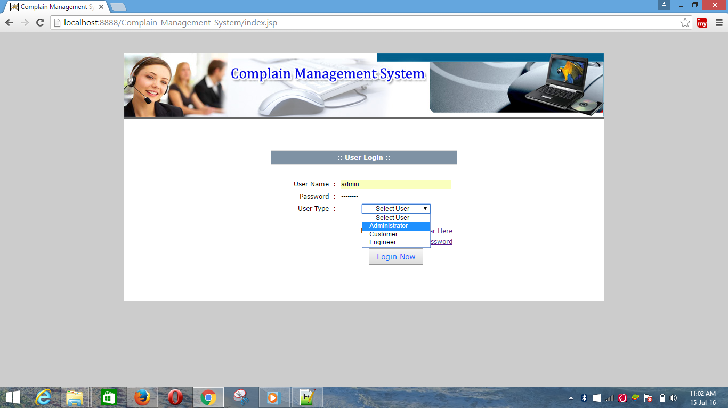

**Login Page Screen Layout**

Online Complain Management System

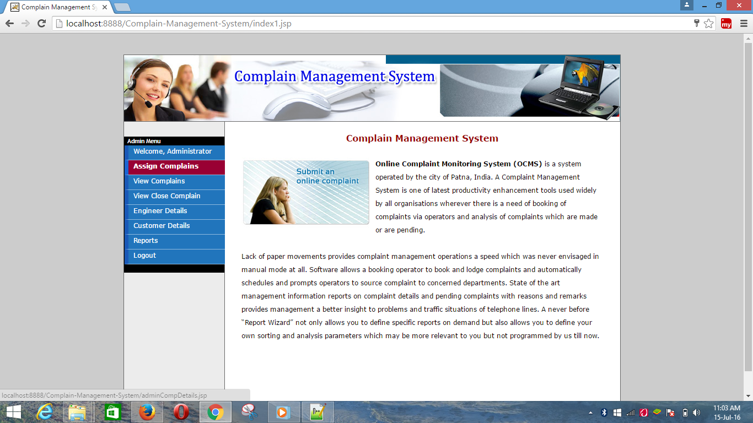

Online Complain Management System

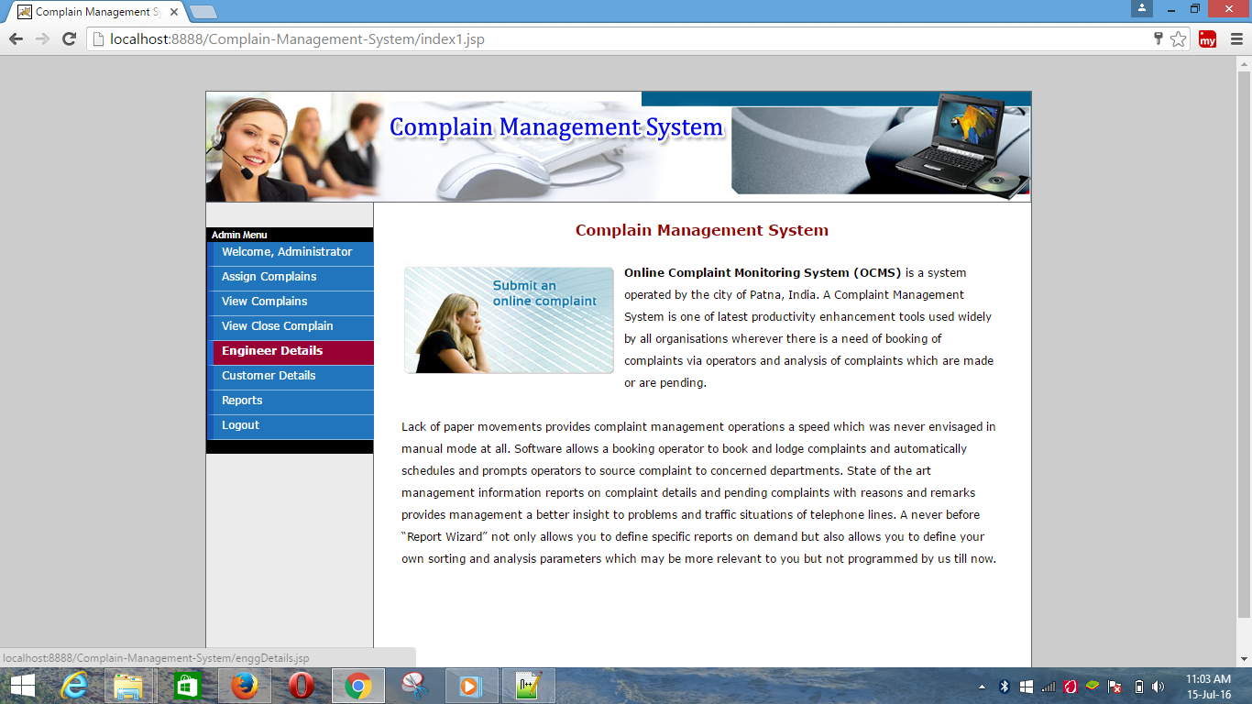

Online Complain Management System

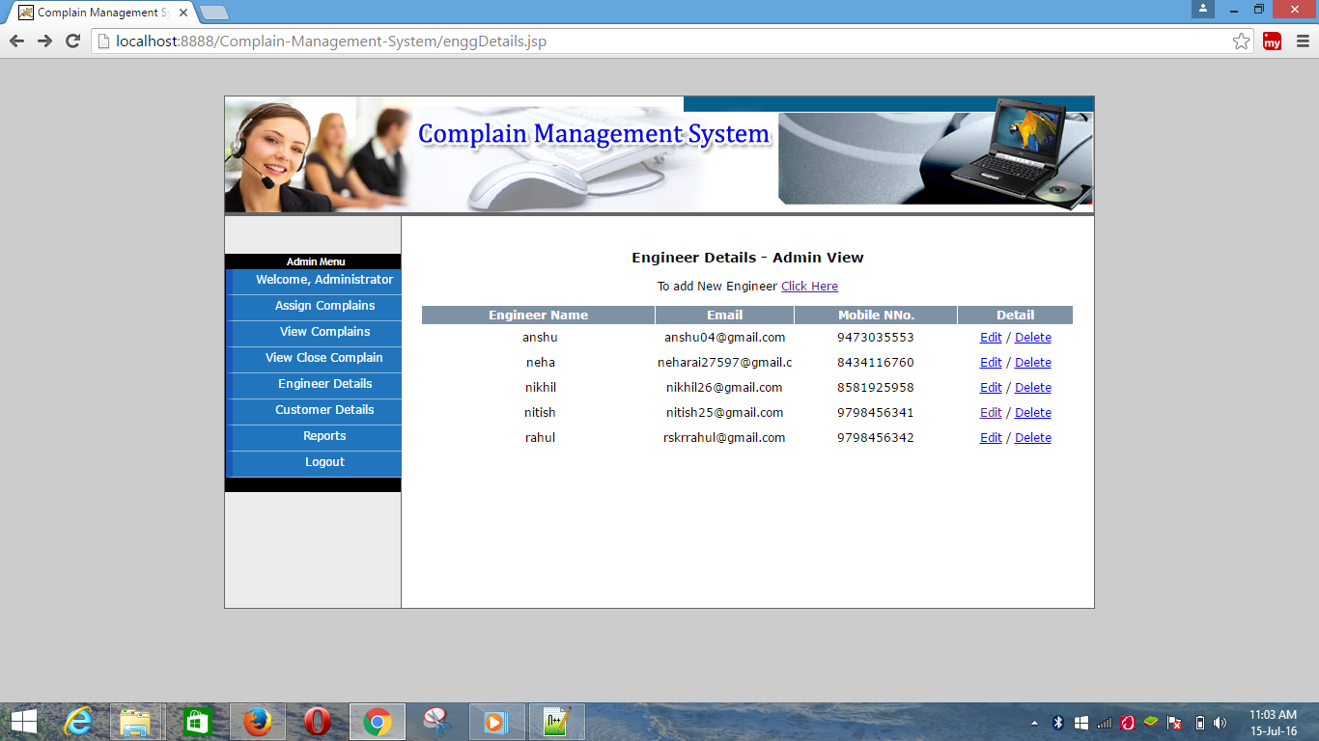

**ENGINEER’S DETAIL SCREEN LAYOUT**

**Online Complain Management System**

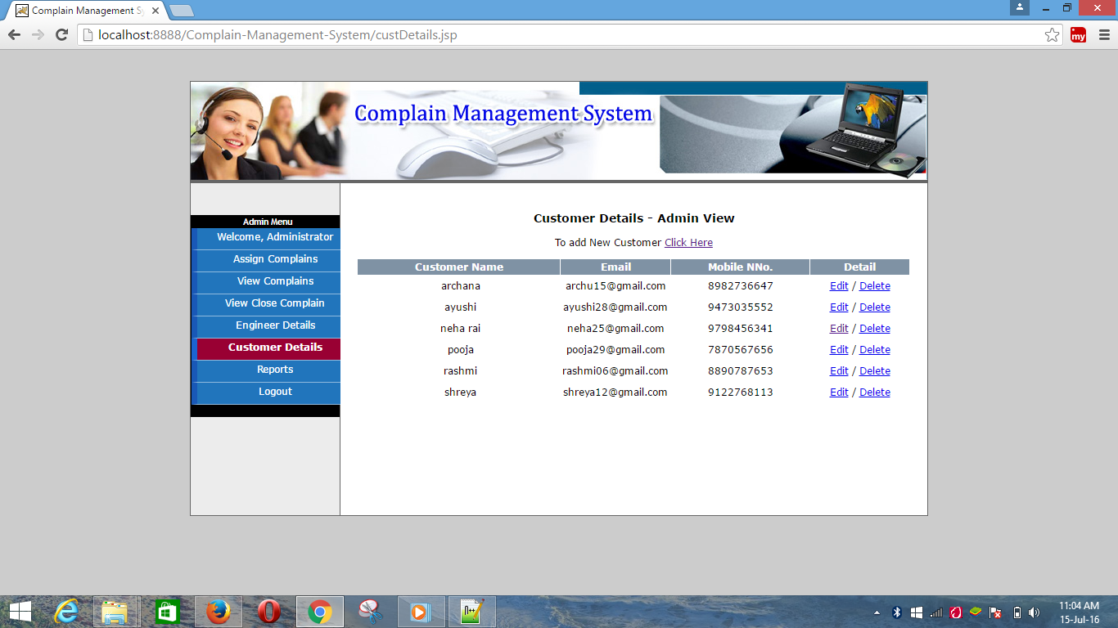

**CUSTOMER’ DETAILS SCREEN LAYOUT**

**Online Complain Management System**

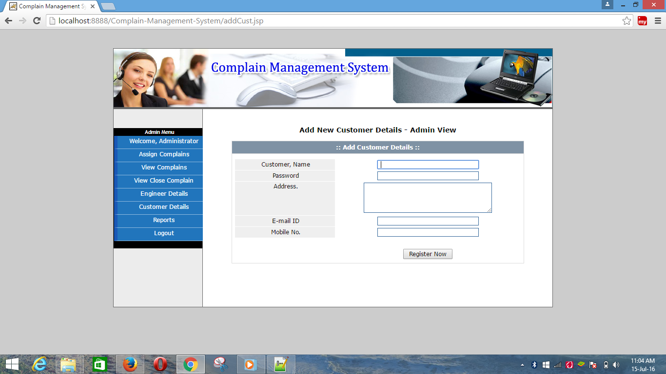

**ADD NEW CUSTOMER SCREEN LAYOUT**

**Online Complain Management System**

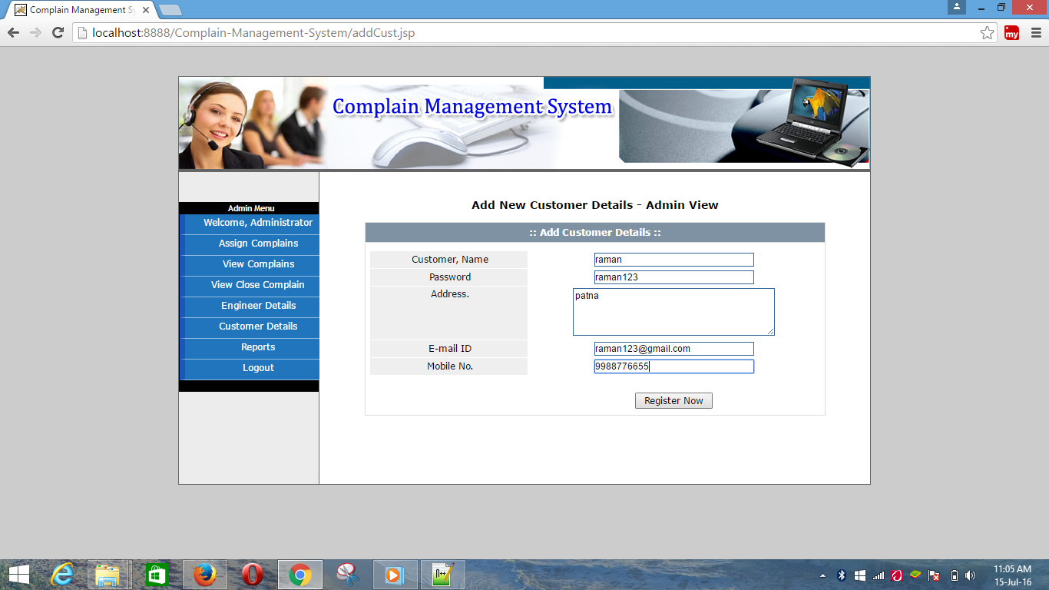

**Online Complain Management System**

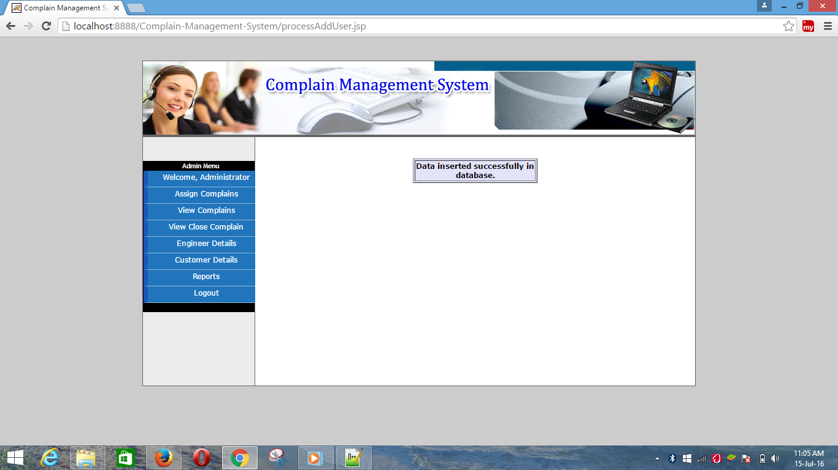

**Online Complain Management System**

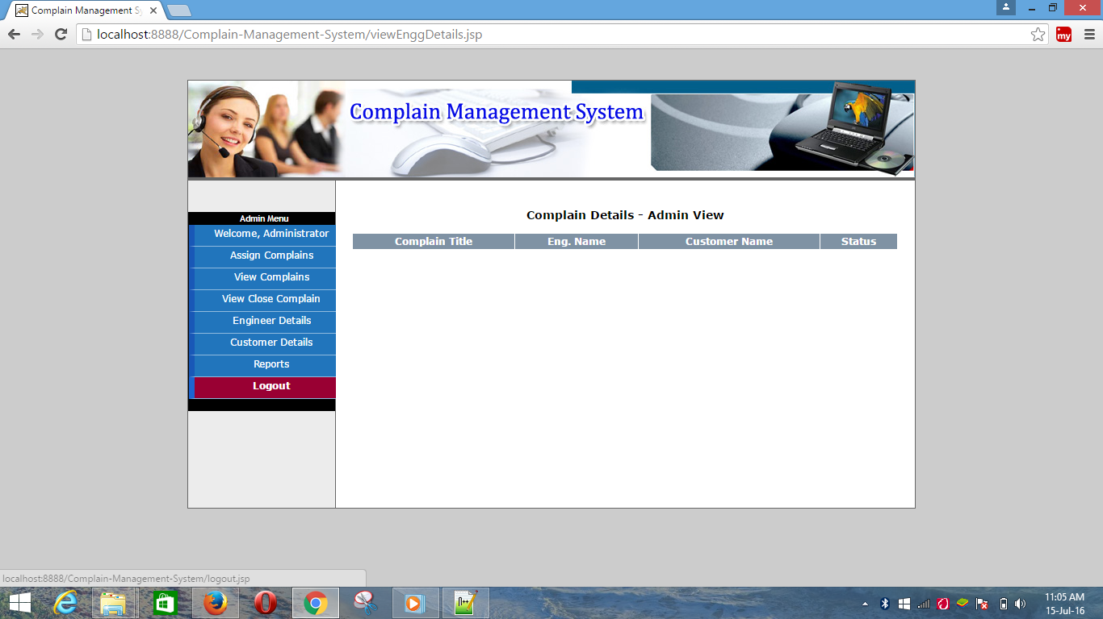

**COMPLAIN DETAIL SCREEN LAYOUT**

**Online Complain Management System**

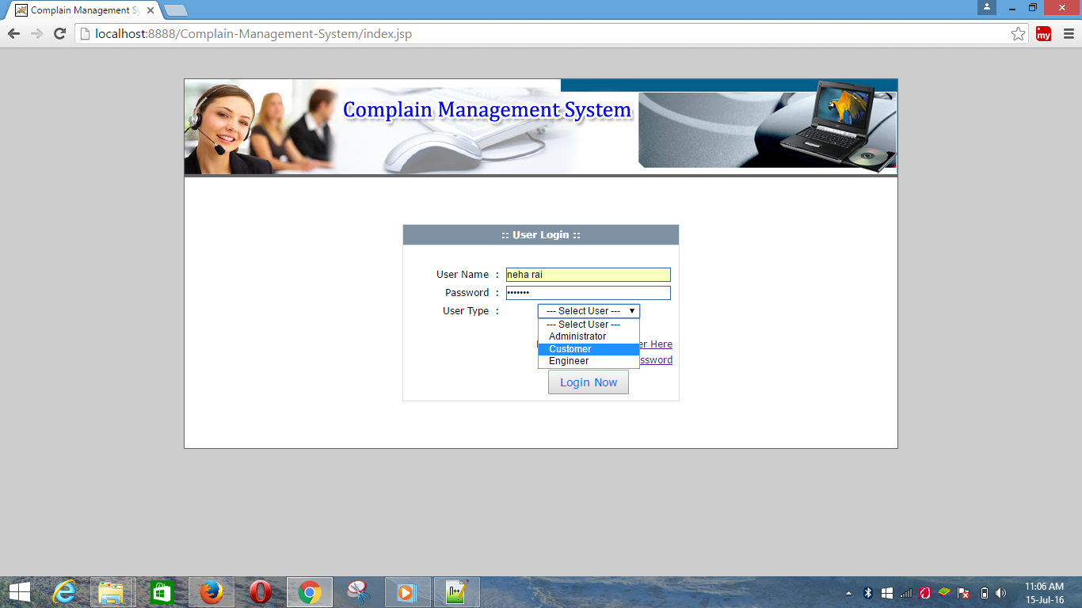

**CUSTOMER LOGIN SCREEN LAYOUT**

**Online Complain Management System**

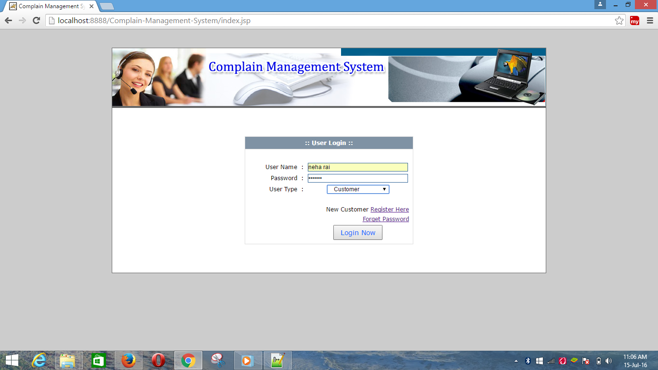

**Online Complain Management System**

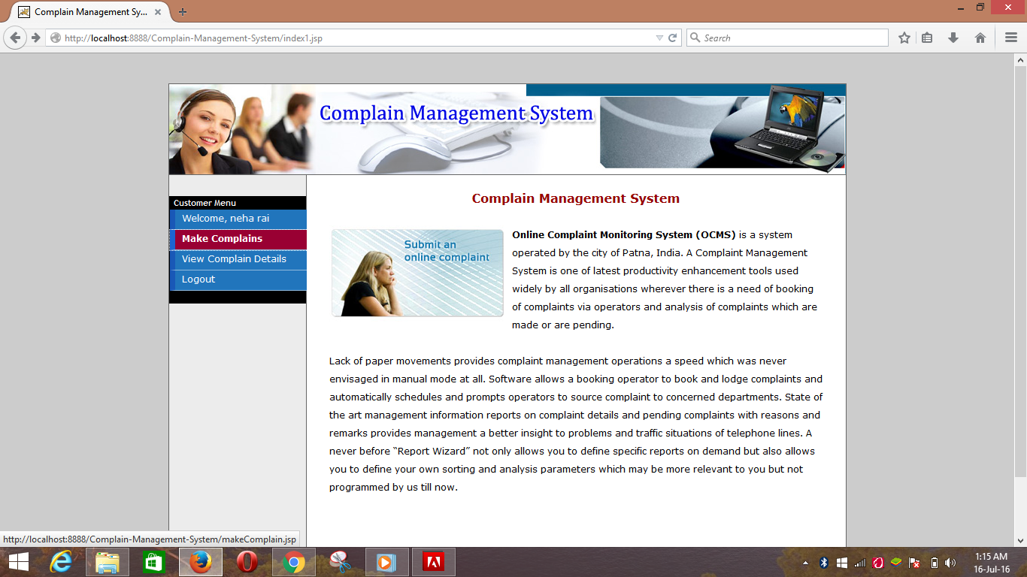

**Online Complain Management System**

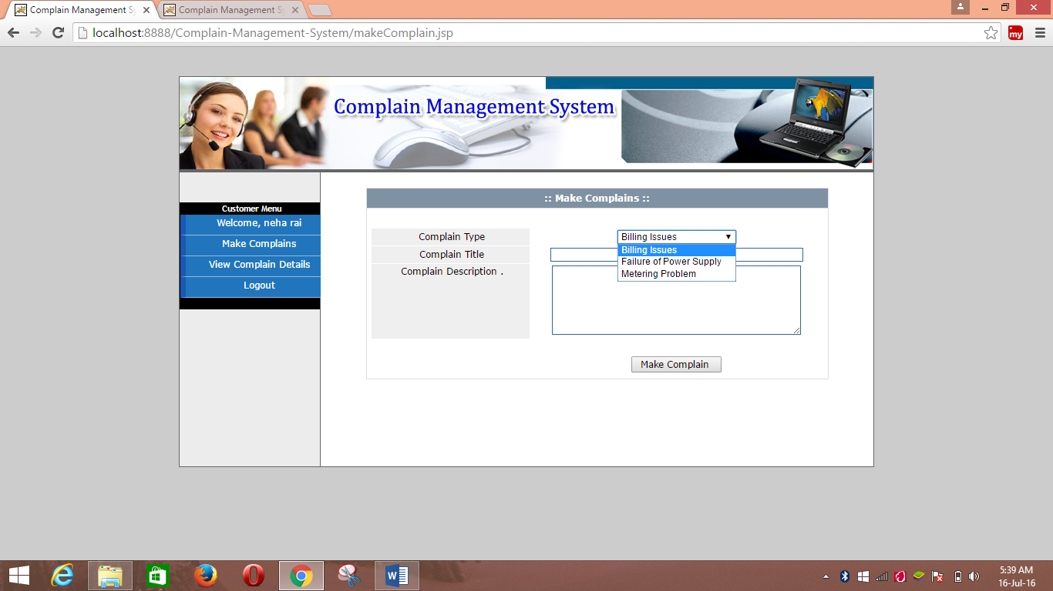

**COMPLAIN MAKING SCREEN LAYOUT**

**Online Complain Management System**

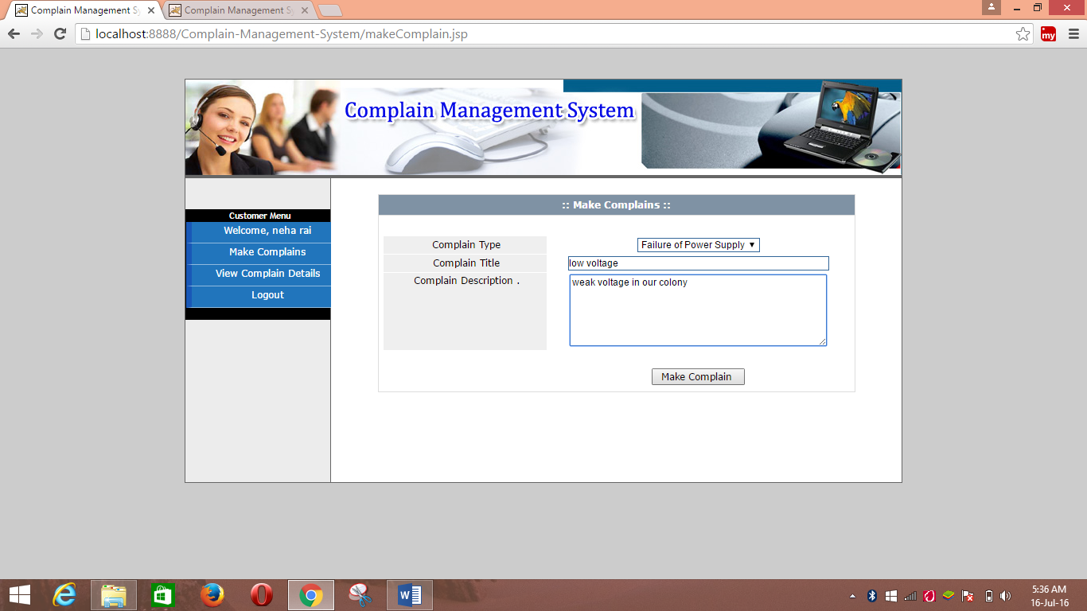

**COMPLAIN – SUBMISSI0N SCREEN LAYOUT**

**Online Complain Management System**

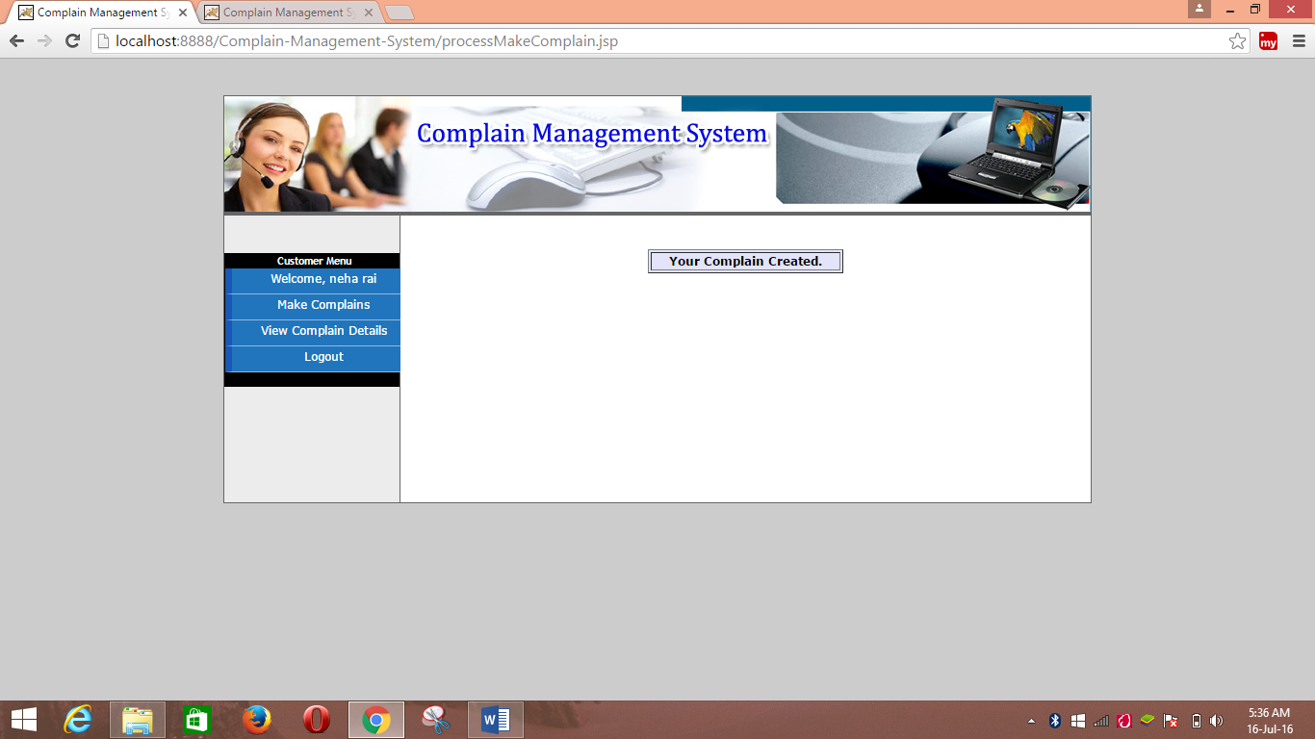

**Online Complain Management System**

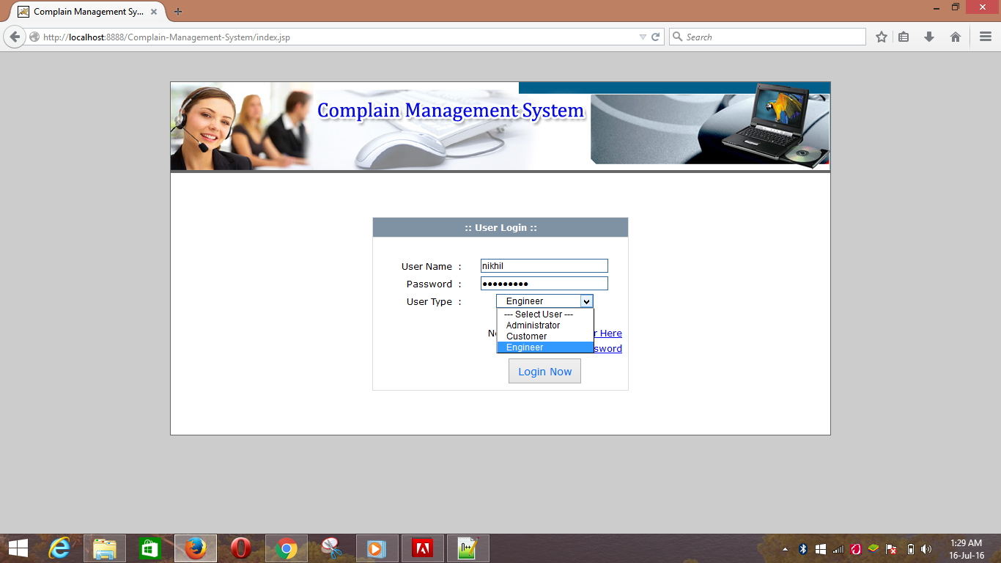

**ENGINEER LOGIN SCREEN LAYOUT**

**Online Complain Management System**

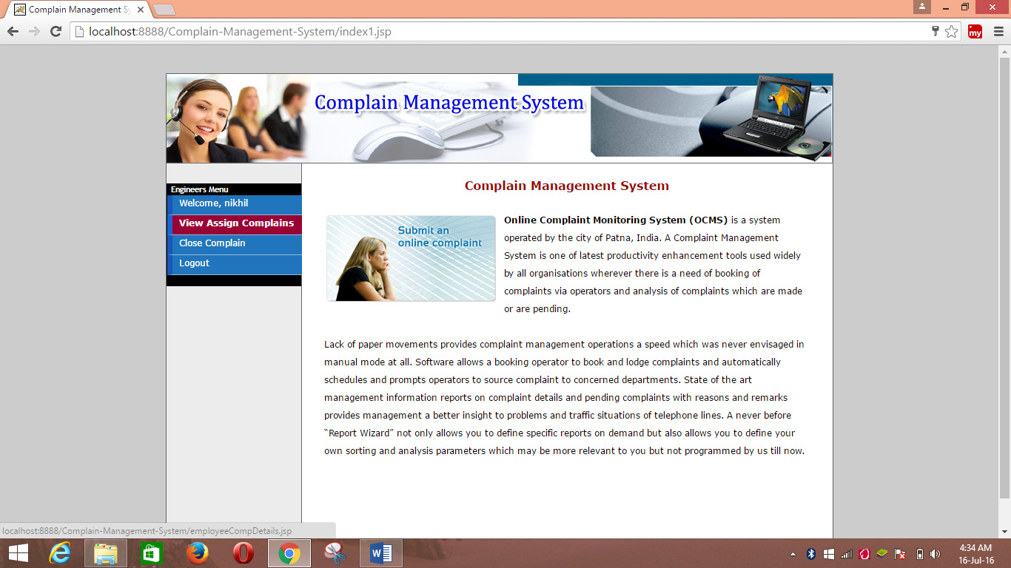

**Online Complain Management System**

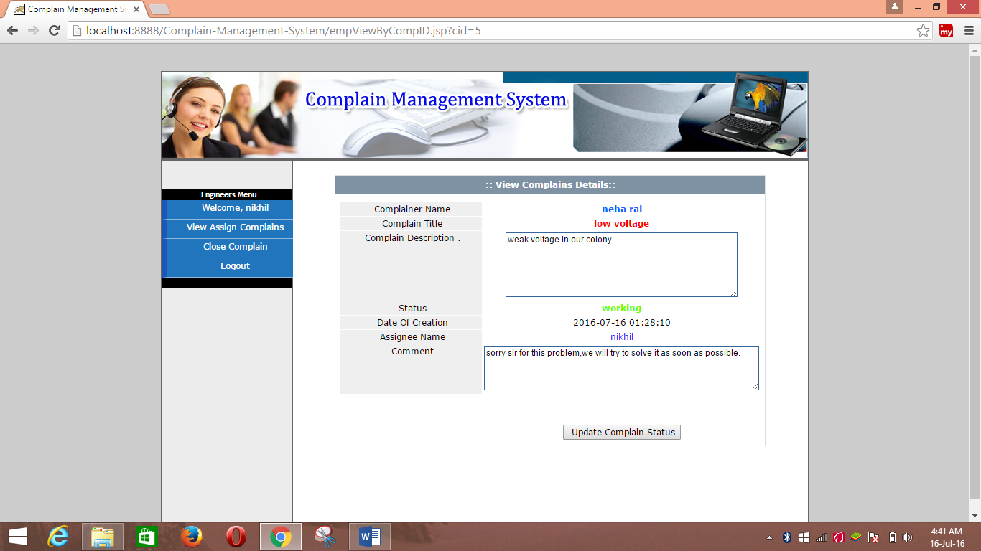

**VIEW COMPLAIN SCREEN LAYOUT**

**Online Complain Management System**

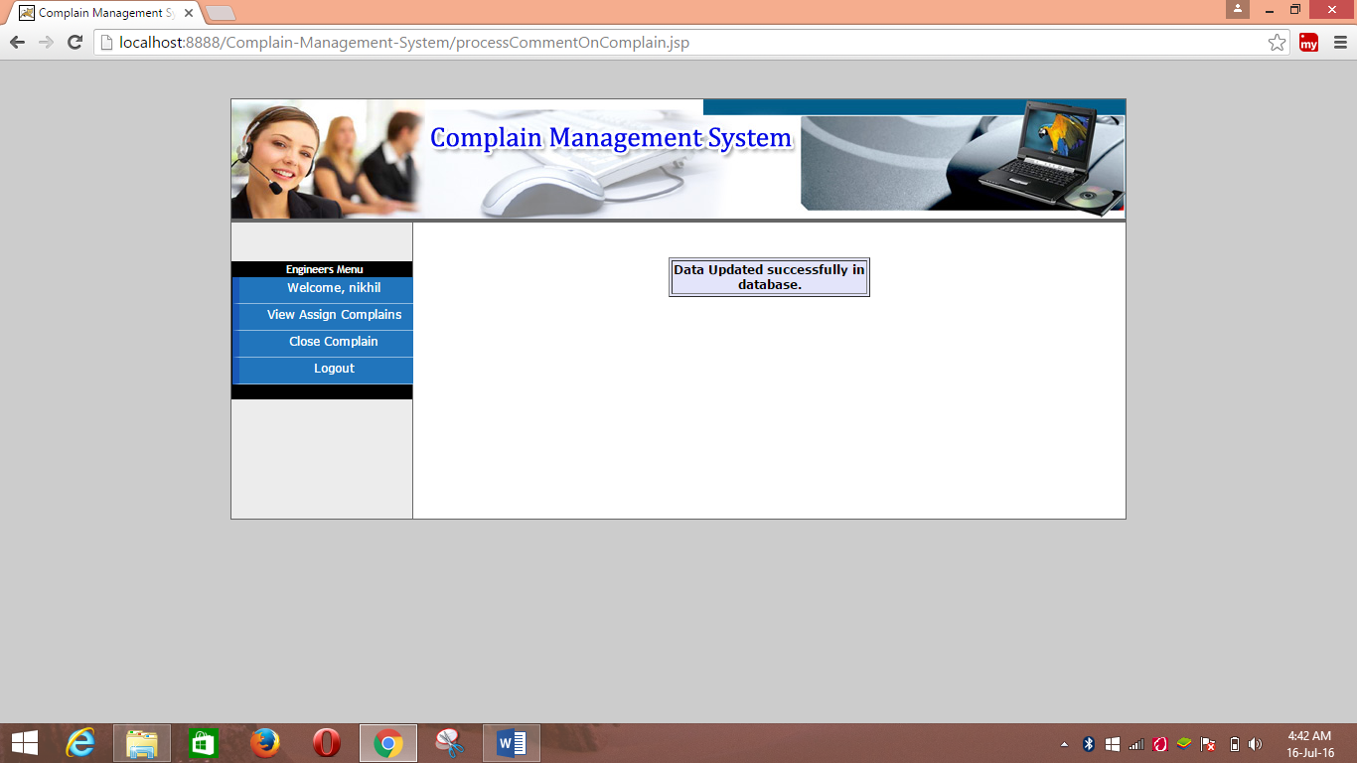

**Online Complain Management System**

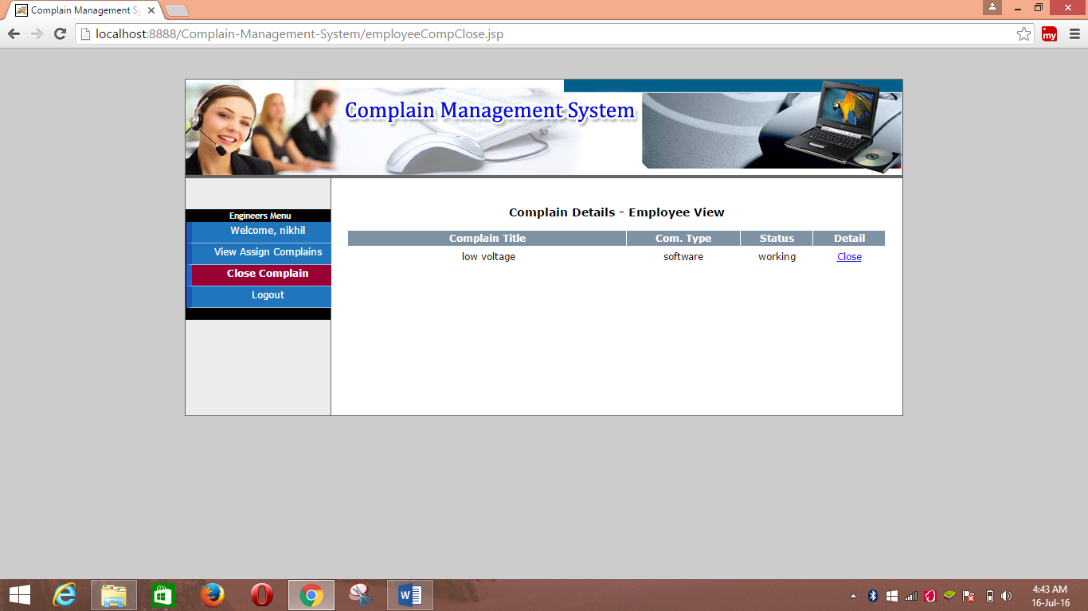

**COMPLAIN – DETAIL SCREEN LAYOUT**

**Online Complain Management System**

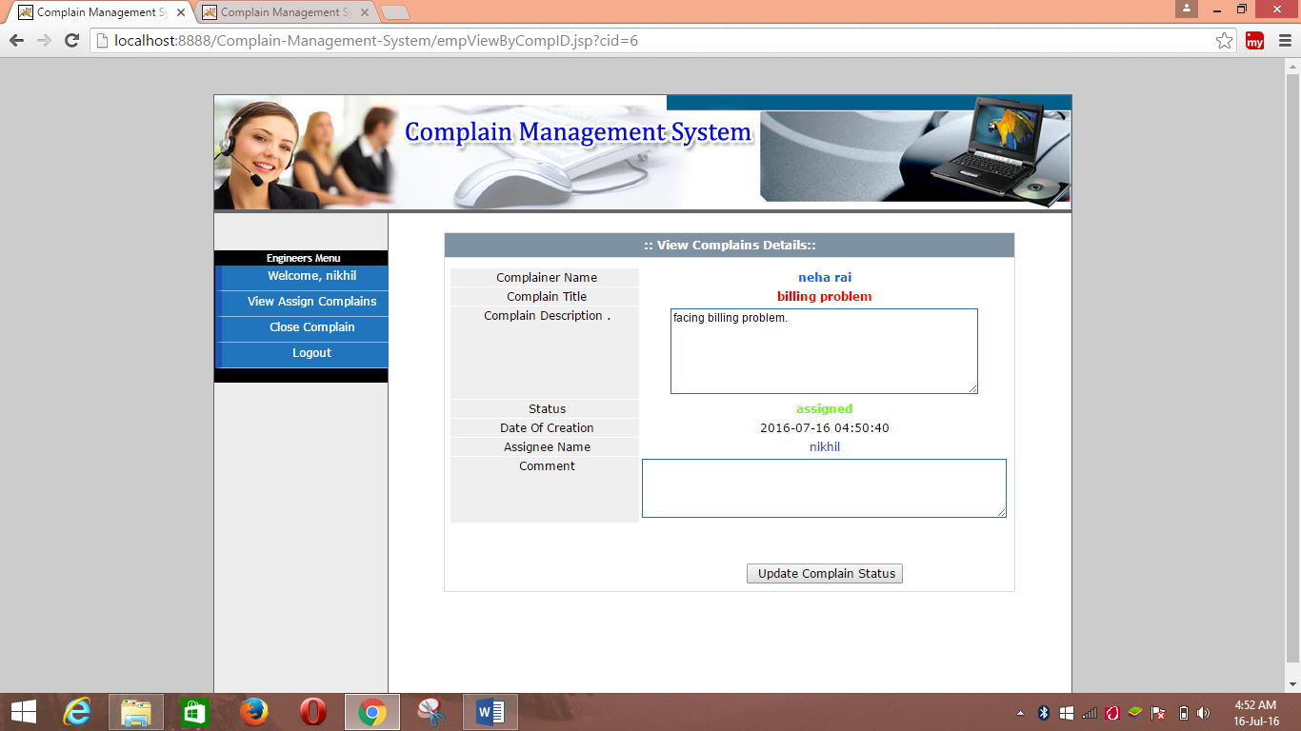

**Online Complain Management System**

MEGASOFT IT SOLUTION

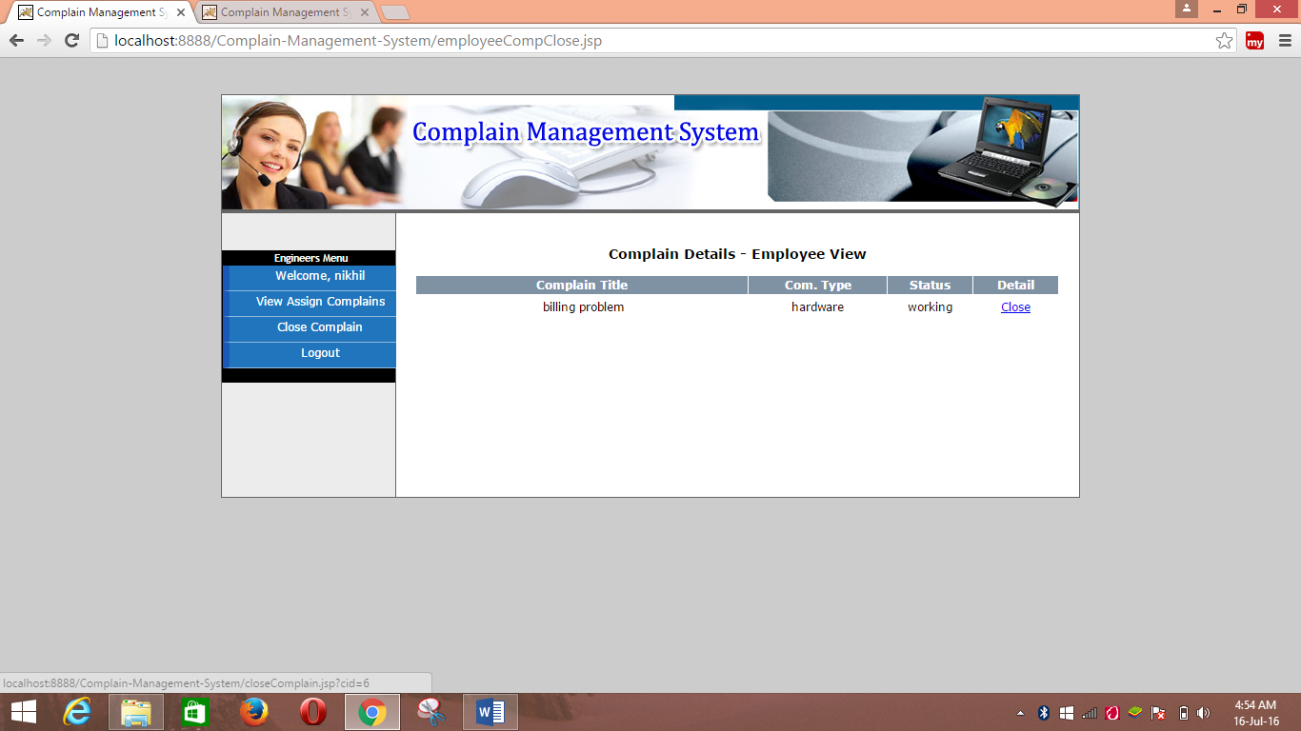

**Online Complain Management System**

MEGASOFT IT SOLUTION

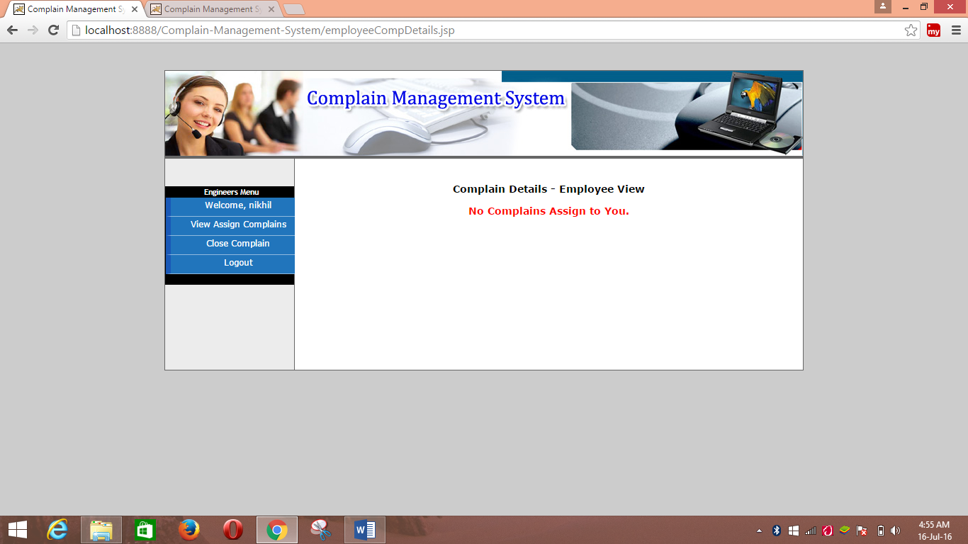

**ONLINE COMPLAIN MANAGEMENT SYSTEM**

**14. Security Mechanism**

Security is a major issue for any software development. Since my project is working on the principal of client-server approach. So, security us a prime concern for it. Different applications use different kind of security mechanism according to their need. In my project security is confined to the user’s level. The system authenticates it’s user by user name and corresponding password. The Administrator provides user name and password to its user. User can change their password but can’t change privileges. Customers have limited access to the system i.e. customers can’t access restricted modules which is reserved for the administrator and employee. Customers will access the system if he/she is a registered user. If anyone tries to access his system he prompted to enter its user name and password.

If it gets the user name into the user list it compares its corresponding password specified by the user. If it does not match, the system denies the access by displaying a message “invalid password”. If the password specified by the user is correct the permission is granted to the user enabling the menu items present in the form. The security is not confined up to this level. After authenticating user name and password system checks the user type of the user ad then provides different privileges to them accordingly.

**ONLINE COMPLAIN MANAGEMENT SYSTEM**

**15. Validation check**

Since the project is network based therefore it will solve only the internal and external queries dedicated to solve the whole restriction of the database as per security reasons and it is also its main purpose. It uses various attribute. Therefore check all sensitive data in each process updating. Constraint name provides validation check for any entry valid data. Therefore, the system stores only valid data.

**16. Limitations of the Project**

Although there are several advantages to uses this project. But there are also some limitations. They are as follows:-

* This project is only worked for specific organization not for all types of organization.
* This project provides only personal level of security just by authenticating user name and password. It does not provide any other security i.e. encryption of data.
* This project is developed specific purpose which is online Complain management system. So complain can be lodge online.
* The system stores large amount of database. Every year the amount of memory space occupied by it increases to a considerable extend, therefore, it requires large amount memory to be reserved for its use.

**ONLINE COMPLAIN MANAGEMENT SYSTEM**

**17. Future Scope and Further Enhancement**

Today we are living in the world of internet, so, with minor changes in the application designing and using JSP, this project report prepared by me, can be implemented on the net and can be used by different dealer for the service station.

Once this project is implemented on the net, one can collect more much information about the company by opening the site say, and can also get their own requirement with the help of this software about 50% to 60% work force can be reduced at a greater extent.

**Benefits of the Applications:**

* Improved level of services to the customers living at different places.
* Improved utilization of the man power working in department.
* Faster and accurate reporting: - Different types of report can be ntegered within no time and same can be produced to the Administrator and there will be no chance of making mistakes
* Performance monitoring: - the performance of the workers and other activities can easily be done with the help of computers.
* Reduction of duplicity: - Some set of data will not be required at different places.
* Reduce document flow between the departments: - the assistance will be free of keeping his document such as tabulation register.
* Better control: - the highest authority of company and the department can have full control on servicing department and he can permit and restrict any person to use this software anytime.
* This project might be helpful to great extent for the servicing.

1. **Google**
2. **Wikipedia**
3. **JSP: 2.0**
4. **W3schools.com**

